 | Faculty of Computing and AI, Air University, Islamabad  Department of Creative Technologies  Data Science | 

“Vision Guard; Detection of Hidden Weapons”

By
Umair Ali 222088
Abid Hussain 222084
Kiran Shehzadi 222132

Supervisor
Mr. Nasir Ayub

Bachelor of Science in Data Science (2022-2026)

DECLARATION

We hereby declare that this software, neither whole nor as a part, has not been copied from any source. It is further declared that we have developed this software and the accompanying report entirely based on our personal efforts. If any part of this project is proven to be copied from any source or found to be a reproduction of some other work, we will face the consequences. No Portion of the work presented has been submitted to any application for any other degree or qualification of this or any other university or institute of learning.

Umair Ali Abid Hussain

Kiran Shehzadi
CERTIFICATE OF APPROVAL
It is to certify that the final year project of BS (Data Science) “Vision Guard; Detection of Hidden Weapons” was developed by Umair Ali (222088), Abid Hussain (222084) and Kiran Shehzadi (222132) under the supervision of Mr. Nasir Ayub and that in his opinion; it is fully adequate, in scope and quality for the degree of Bachelors of Science in Data Science.

---------------------------------------
Supervisor

---------------------------------------
External Examiner

---------------------------------------
Head of Department
(Department of Creative Technologies)

Executive Summary
The "Vision Guard" project is made to solve a problem. This problem is finding weapons in places that need to be very secure. Most security systems do not catch threats that are not easy to see. To fix this the "Vision Guard" project only looks for weapons. It uses sets of data that include thermal imaging. These images show patterns that help the system find objects hidden under clothes. This gives us a security advantage that we did not have before.

The "Vision Guard" system uses the YOLOv11 model. This model is trained to work with images. It can do instance segmentation, which means it can create an image of hidden weapons. This model is better than detection tools. It does not just tell us where an object is it clearly defines the shape of the threat.

The "Vision Guard" project also uses logic to handle security responses. The system has been tested a lot to make sure the thermal camera feeds and the YOLOv11 model work together. The "Vision Guard" is a tool that helps security teams spot and stop hidden threats.

It combines processing with thermal technology to set a better standard for security. This provides a way to improve how we protect buildings and public areas. The "Vision Guard" system makes sure we can catch threats by constantly monitoring. This helps make our public and private places safer for everyone. The "Vision Guard" project is important, for our safety.

Acknowledgement
All praise is to Almighty Allah who bestowed upon us a minute portion of His boundless knowledge by virtue of which we were able to accomplish this challenging task.

We are greatly indebted to our project supervisor, Mr. Nasir Ayub. Without their personal supervision, advice, and valuable guidance, completion of this project would have been doubtful. We are grateful to them for their encouragement and continual help during this work.

And we are also thankful to our parents and family who have been a constant source of encouragement for us and instilled in us the values of honesty & hard work.

Umair Ali Abid Hussain

Kiran Shehzadi
Abbreviations
AI | Artificial Intelligence
IR | Infrared
YOLO | You Only Look Once
CCTV | Closed-Circuit Television
RGB | Red, Green, Blue (Standard Color Model)
FPS | Frames Per Second
UI/UX | User Interface / User Experience
GPU | Graphics Processing Unit
RDMS | Relational Database Management System
IDE | Integrated Development Environment
DIP | Digital Image Processing
DBMS | Database Management System
FR | Functional Requirement
NFR | Non-Functional Requirement
MTBF | Mean Time Between Failures
RBAC | Role-Based Access Control
Table of Contents
Chapter 1 9
Introduction 9
1.1 Vision Statement: 9
1.2 Related System Analysis/Literature Review: 9
1.3 Project Deliverables: 11
1.4 System Limitations/Constraints: 11
1.5 Tools and Technologies: 12
1.6 Relevance to Course Modules: 12
Chapter 2 14
Problem Definition 14
2.1 Problem Statement: 14
2.2 Problem Solution: 15
2.3 Objectives of the Proposed System: 15
2.4 Scope: 16
2.5 Modules: 16
2.5.1 Module for Image Preprocessing: 16
2.5.2 Detection Engine Module (YOLOv11 Integration): 16
2.5.3 Alert and Notification Module: 17
2.5.4 The History & Detection Log Module: 17
2.5.5 Module for User Management: 17
2.5.6 Configuration and Settings Module: 17
Chapter 3 19
Requirement Analysis 19
3.1 User classes and characteristics: 19
3.2 Requirement Identifying Technique: 20
3.3 Functional Requirements: 29
3.4 Non-Functional Requirements: 34
3.4.1 Reliability: 34
3.4.2 Usability: 35
3.4.3 Performance: 35
3.4.4 Security: 35
3.5 External Interface Requirements: 36
3.5.1 User Interface Requirements: 36
3.5.2 Software interfaces: 37
3.5.3 Hardware interfaces: 38
3.5.4 Communications interfaces: 39
Chapter 4 41
Design and Architecture 41
4.1 Architectural Design: 41
High-Level Functional Flow 41
4.1.1 Initial Design Stage: Box and Line Diagram: 41
4.1.2 Architectural Mapping: Multi-Tiered Structure 42
4.1.3 AI and Analytics Layer: 43
4.1.4 Data Access Layer: 43
4.2 Design Models: 44
4.2.1 Activity Diagram: 44
4.2.2 Class Diagram: 48
4.2.3 System Sequence Diagrams: 50
4.2.4 State Transition Diagram: 53
4.3 Data Design 54
4.3.0.1 Information Domain Transformation: 54
4.3.0.2 Data Storage, Processing, and Organization: 54
4.3.0.3 Databases and Data Storage Items: 55
4.3.1 Data Dictionary: 55
4.4 Human Interface Design: 57
4.4.1 Screen Images: 57
4.4.2 Screen Objects and Actions: 58
Chapter 5 60
Implementation 60
5.1.2 Algorithm 2: Dataset Preparation 61
5.2 External APIs/SDKs: 61
5.3 User Interface: 62
Chapter 6 68
Testing and Evaluation 68
6.1 Unit Testing: 68
6.1.1 Unit Testing 1: Thermal Image Pre-processing Module 68
6.1.2 Unit Testing 2: YOLOv11 Model Loading 68
6.1.3 Unit Testing 3: Model Loading 68
6.1.4 Unit Testing 4: Model Loading 69
6.2 Functional Testing: 69
6.2.1 Functional Testing 1: Hidden Weapon Detection 69
6.2.2 Functional Testing 2: Real-Time Alert Generation 69
6.2.3 Functional Testing 3: User Authentication 70
6.3 Business Rules Testing: 70
6.4 Integration Testing: 71
6.4.1 Integration Testing 1: Thermal Camera and Detection Engine 71
6.4.2 Integration Testing 2: Detection Engine and Alert Module 71
6.4.3 Integration Testing 3: Detection Log and Database Module 71
Chapter 7 72
Conclusion and Future Work 72
7.1 Conclusion: 72
7.2 Future Work: 72
• References: 74

List of Figures

Figure 3.2.1 Use Case Diagram 24
Figure 4.1.1 Box and Line Diagram 44
Figure 4.1.2 Component-based Layered Architecture 45
Figure 4.2.1.1 Live Detection and Monitoring: 46
Figure 4.2.1.2 Alert Notification System 47
Figure 4.2.13 Security Dashboard Monitorin 47
Figure 4.2.1.4 Data Training and Model Updates 48
Figure 4.2.1.5 System Configuration and Admin 49
Figure 4.2.1.6 Review Detection History 49
Figure 4.2.1.7 User Authentication and Session Management 50
Figure 4.2.2 Class Diagram 52
Figure 4.2.3.1 Live Detection and Monitoring 53
Figure 4.2.3.2 Alert Notification System 53
Figure 4.2.3.3 Security Dashboard Monitoring 54
Figure 4.2.3.4 Data Training and Model Updates 54
Figure 4.2.3.5 System Configuration and Admin 55
Figure 4.2.3.6 Review Detection History 55
Figure 4.2.3.7 User Authentication and Session Management 56
Figure 4.2.4. State Transition Diagram 56

List of Tables

Table 1: Related System Analysis with proposed project solution 11
Table 2: Tools and Technologies used for “Vision Guard” 13
Table 3: Tools and Technologies used for “Vision Guard”…………………………………………….....20
Table 4: Event-Response Table for “Vision Guard” 29
Table 5: Description of FR-1………………………………………............................................................30
Table 6: Description of FR-2………………………………………...……………………………….…....31
Table 7: Description of FR-3………………………………………...…………………………….………31
Table 8: Description of FR-4………………………………………...…………………………….……....32
Table 9: Description of FR-5………………………………………...………………………….………....32
Table 10: Description of FR-6………………………………………...……………………….…………..33
Table 11: Data Dictionary………………………………………...…………………………….……........59
Table 12: Screen Objects and Actions………………………………………...………………….………..62
Table 13: Details of APIs used in the project………………………………………...…………..………..64

Chapter 1

Introduction
In this chapter, an insight into the “Vision Guard” project is provided, which was designed to improve modern security systems through automatic detection of concealed weapons. Today, security is one of the important issues faced across different countries around the world, where regular cameras fail to detect any threat concealed beneath clothes or in bags for obvious reasons. To counter this issue, we have designed this system using the Hidden Weapon Detection technique along with Thermal Imaging and Infrared (IR) data sets. Regular cameras make use of visible light, but thermal cameras work on the principle of detecting heat signatures and, therefore, can easily identify weapons. The entire system is based on the YOLOv11 AI model, which allows real-time detection of weapons at a pixel-level accuracy.

Vision Statement:
For security personnel and high-stakes organizations who need a proactive way to detect concealed threats that are invisible to the naked eye, the Vision Guard is a hidden weapon detection system that uses YOLOv11 and thermal imaging to identify weapons under clothing in real-time. Unlike standard CCTV cameras and manual physical frisking, our product offers an automated, non-intrusive, and highly accurate detection layer that can see through visual barriers using heat signatures, ensuring immediate alerts without human delay.

1.2 Related System Analysis/Literature Review:
Most of the time weapon detection systems use cameras that can only see things in colour. These systems are only good, at finding weapons when they are easy to see in the picture. They use ways of finding objects that do not work well when it is dark or when something is blocking the view of the weapon. Weapon detection systems also have a time finding things when they are hidden. Some systems can use cameras that can see heat but these are usually only found in airports and are very costly. These special systems are also very big. Cannot be easily added to the normal online security monitors. Weapon detection systems that use imaging are really good but they are not used much because of the cost. Weapon detection systems need to be improved so they can find weapons even when they are hidden under clothing.
Table 1: Related System Analysis with proposed project solution
Application Name | Weakness | Proposed Project Solution
Standard CCTV Analytics | Standard CCTV cameras can only see weapons that are out in the open. They do not work well if someone hides a weapon under their jacket or, in a bag. | Vision Guard uses Thermal Imaging to find heat. This means it can see through clothes and find weapons like guns. Vision Guard is really good at detecting heat signatures so it is very useful, for identifying concealed weapons with the help of Thermal Imaging.
Traditional Bounding Box Detectors (YOLOv3/v4) | Traditional Bounding Box Detectors like YOLOv3 and YOLOv4 just draw a box around the object. This can be a problem because it often leads to positives when things are cluttered or messy. The Traditional Bounding Box Detectors are not very good at handling environments. Traditional Bounding Box Detectors such, as YOLOv3 and YOLOv4 need to be improved to reduce positives in these situations. | The system uses YOLOv11. This YOLOv11 provides a mask, for each pixel. This mask helps identify the shape of the weapon. The YOLOv11 makes the system more accurate when it comes to finding weapons.
Manual Security Scanning | High human error and slow processing times as guards have to manually watch every screen or perform physical frisking. | Provides an Automated Real-time Dashboard that triggers instant visual and auditory alerts based on AI detection, reducing human dependency.
Basic IR Motion Sensors | Can detect movement but cannot distinguish between a human carrying a phone and a human carrying a hidden weapon. | Uses a trained deep learning model on specialized datasets to specifically classify and segment hazardous objects from everyday items.

1.3 Project Deliverables:
The “Vision Guard” system provides a comprehensive set of software assets and functional modules designed for high-precision security monitoring. Based on the system's architecture and user interface, the following products and features are delivered as part of this project:
• Secure User Authentication System: A portal for secure access including account registration, sign-in, and error handling for invalid credentials.
• Tactical Threat Detection Core: A high-tech monitoring dashboard capable of real-time weapon signature tracking and video analysis.
• Multi-Format Video Processing: A system that accepts and processes various video formats for threat detection.
- Live Detection Analytics: A visual monitoring tool that displays the total number of detections, current system status, and active session counts.
- Automated Threat Alert Gallery: A specialized interface that captures and lists every detected weapon, showing the thermal snapshot, weapon type, and probability percentage.
• Detailed Session History Archive: A logging system that records and stores every monitoring session with file names, detection counts, and exact timestamps.
• The Customizable AI Control Panel: is where you can change things to suit your needs. This is the place where you can adjust the Customizable AI Control Panel settings like the Confidence Threshold and the Sampling FPS, which is the number of frames the Customizable AI Control Panel shows per second. The Customizable AI Control Panel has Hardware Interface Controls that let you manage the system alerts, like the sound that the Customizable AI Control Panel makes to alert you to something. You can turn this sound on or off, with the Customizable AI Control Panel.
• Model Management System: A feature that shows the current status of the AI model and allows the user to "Reload" it for updates.
• Professional Dark-Theme UI/UX: A high-fidelity, user-friendly interface designed specifically for high-stress security monitoring environments.

1.4 System Limitations/Constraints:
LI-1: The system is specifically designed for thermal and infrared imaging; therefore, its performance may be significantly reduced if only standard RGB cameras are used without the necessary thermal sensors.
LI-2: High-speed real-time segmentation using YOLOv11 requires a dedicated GPU (Graphics Processing Unit) to maintain a stable frame rate and avoid latency in generating alerts.
LI-3: The detection range is limited by the resolution and field of view of the thermal camera being used; weapons hidden beyond the optimal sensor range may not be segmented accurately.
LI-4: Environmental factors such as extreme ambient heat or heavy rain may interfere with the thermal signatures, potentially leading to a decrease in the system's precision during outdoor operations.
LI-5: The alert system requires a stable network connection to sync the camera feed with the web-based dashboard for real-time monitoring and auditory notifications.

1.5 Tools and Technologies:
The following table outlines the comprehensive set of tools and technologies employed to design, develop, and deploy the “Vision Guard” system, ensuring high-performance thermal imaging and real-time AI detection.

Table 2: Tools and Technologies used for “Vision Guard”
Tools  And  Technologies | Tools | Version | Rationale
 | Visual Studio Code | 2024 | IDE
 | SupaBasex | 2022 | PostgreSQL (RDBMS)
 | Canva | 2.0 | Design Work
 | Technology | Version | Rationale
 | React JS | 19.2 | Front-end Development
 | FastAPI | 3 | Back-end Development
 | Python | 3.11 | Back-end Development

1.6 Relevance to Course Modules:
The “Vision Guard” project is a practical application of various core subjects studied throughout the Data Science degree. The foundation of the project lies in Digital Image Processing (DIP), where techniques for image enhancement were applied to process thermal and infrared feeds. The core intelligence of the system is based on Artificial Intelligence (AI) and Deep Learning, specifically through the implementation of the YOLOv11 model to automate threat detection.
Furthermore, the project incorporates principles of Software Engineering and Object-Oriented Programming (OOP) to build a modular and scalable system architecture, following the iterative development process. The management of detection logs and user authentication was handled using concepts from Database Management Systems (DBMS), while the real-time dashboard was developed based on Data Analysis and Visualization principles to provide a clear and user-friendly security interface. Overall, the project successfully integrates multiple disciplines to solve a complex, real-world security challenge.

Chapter 2

Problem Definition
This chapter describes the precise security challenges that the "Vision Guard" project is designed to overcome, focusing on the limitations of current surveillance technology in detecting non-visible threats. It outlines the necessity of transitioning from reactive to proactive monitoring and concludes by detailing the expected outcome of integrating thermal intelligence into a real-time security framework.
The “Vision Guard” project is working to fix a problem with modern surveillance systems. These systems can't detect threats that you can't see with your eyes. Most surveillance systems use cameras that only work with visible light. This creates a security gap because people can hide weapons like handguns or knives under their clothing and not get caught. Manual methods like searching people physically are slow and can cause delays. Human operators who monitor camera feeds can get tired and distracted. Standard cameras also don't work well in light, fog or smoke. These conditions are often used during security breaches.
The “Vision Guard” project uses imaging and a special model called YOLOv11 to identify objects based on their heat signatures. This helps to overcome the limitations of cameras. The result is a system that works 24/7 and sends alerts right away. This helps to keep people safe by stopping hidden threats before they can be used to harm anyone. The Vision Guard project is about using thermal imaging and the YOLOv11 model to detect concealed threats. This project helps to ensure an environment by neutralizing concealed threats, like handguns or knives before they can be used in a harmful incident.

2.1 Problem Statement:
The security we have today has a problem. Modern surveillance systems can't detect threats that we can't see. Most institutions use RGB cameras that only work with visible light. This means they can't see through things like clothing or bags. This creates a security gap where people can easily hide things like guns or knives and get into areas without being seen. The usual way to find these threats is by frisking people, which can be intrusive and slow. Manual checkpoints can cause crowds, which can also be targets for security threats.

Security guards who watch camera feeds for hours get tired. Lose focus. This makes it more likely that a hidden weapon will be missed. Standard surveillance equipment doesn't work well in light, fog or smoke. Now there is no widely used automated technology that can find hidden dangers before they're used. Without a way to detect objects based on what they're not just what they look like security is mostly reactive. This means threats are only found after something has already happened. Relying on motion sensors often causes a lot of false alarms, which can make security teams less alert to real dangers. Not having a way to monitor for hidden items that does not involve touching people leaves areas open, to surprise violence. All these issues show that modern security has a weakness that needs to be fixed to keep people safe.

2.2 Problem Solution:
The “Vision Guard” system is a way to watch people without being too invasive. It uses cameras that can see heat and a computer program called YOLOv11 to find things that are hidden under clothes. This system is good at finding things that regular cameras cannot see. It works by looking for things that are not normal like something hidden under a jacket. This means that people do not have to be searched by hand, which can be slow and annoying. It is especially useful in places like airports, malls and schools where a lot of people are walking around.

The people in charge can use a website to watch what the cameras are seeing in time. If the system finds something that might be a weapon it sends an alert away. This helps the security people react faster in an emergency. The Vision Guard system is good at finding things that might be a threat before they become a problem. It can tell the difference between a phone and a gun, which is very important.

The system works even when it is very dark or foggy which is when regular cameras do not work well. It also reduces the chance of error because it is a machine that is watching and not a person who might get tired or distracted. All the times that the system finds something are recorded which helps the security people understand what happened and how to make things safer. The Vision Guard system is a help, to the people who are trying to keep everyone safe and it does this without bothering people or invading their privacy.

2.3 Objectives of the Proposed System:
OBJ-1: The system should be able to find concealed weapons like handguns and knives a lot than the old systems that just use normal cameras. It should be able to find these things 90% often.
OBJ-2: The system should make the lines at security checkpoints move faster. It should be able to check people so that it takes 50% less time to get through.
OBJ-3: When the system finds something it should tell the security people away. It should not take than 2 seconds to send an alert.
OBJ-4: The system will use a kind of technology called YOLOv11 to find threats very precisely. This means it will be able to say where the threat is and it will not make as many mistakes. It should reduce the number of alarms by at least 30%.
OBJ-5: The system should be good enough that security people do not have to search everyone who comes into a secure area. This way people can. Go without being bothered. The security system will make sure everyone is safe, without being intrusive.
OBJ-6: Maintain a digital, time-stamped log of 100% of detection events within the database to facilitate accurate post-incident forensic audits and reporting.

2.4 Scope:
The “Vision Guard” project aims to create an intelligent system that can detect hidden weapons using thermal cameras. The main part of the project is about using the YOLOv11 model to find things like knives or guns that people might try to hide under their clothes. This system is different from cameras because it uses heat signatures to spot things that we cannot normally see. The YOLOv11 model will help us find these items.
The software will have a real-time dashboard where security people can watch the video and get alerts right away. If the YOLOv11 model finds a weapon the system will make a sound. Show a warning on the screen so the security guard can act fast. The YOLOv11 model is important here. Another key part of the project is saving all the times the YOLOv11 model detects something in a database, with the time and date for our records.
The system is built for use at entry points or checkpoints where many people go through. It’s important to note that this project is focused only on detecting weapons hidden under clothing and not on scanning bags or suitcases. The system processes video footage, as the main goal is to identify threats. We are not including drones; the system works with camera setups. The project handles the software part, like processing the video and sending alerts, assuming a thermal camera is already connected. The overall goal is to provide a quick and non-intrusive way to keep secure areas safe without requiring people to stop for a physical search.

2.5 Modules:
This section describes the various functional modules of the “Vision Guard” system. These modules work together to process thermal data, detect threats, and manage security operations effectively.

2.5.1 Module for Image Preprocessing:
FE-1: Convert raw thermal input into a standardized colour format for model compatibility.
FE-2: Normalize pixel values and scale images to the required input size for the YOLO engine.
FE-3: Apply noise reduction filters to clean thermal heat signatures, ensuring clearer detection in varying conditions.

2.5.2 Detection Engine Module (YOLOv11 Integration):
FE-1: Load the trained YOLOv11 model to perform real-time inference on incoming thermal frames.
FE-2: Generate pixel-level segmentation masks to highlight the exact shape and size of the detected weapon.
FE-3: Output bounding boxes and classification labels, for example: Handgun, Knife, with associated confidence scores.

2.5.3 Alert and Notification Module:
FE-1: I want the system to immediately sound an alarm on the dashboard when it detects a threat that's very likely to be real.
FE-2: When a threat is detected I would like the system to show a pop-up warning and highlight the threat on the video feed. This will help me quickly see where the threat is. The system should use masks to show what it thinks is a threat.
FE-3: To avoid many false alarms the system should only alert me if it is very sure that what it has detected could be a weapon. This means setting a bar for what counts as a threat so I only get alerts, for things that are probably weapons.

2.5.4 The History & Detection Log Module:
FE-1: Automatically save a snapshot of every detection event along with the highlighted threat area.
FE-2: Store essential metadata in the database, including confidence percentage and precise timestamps.
FE-3: It would be really helpful to have a way to look back at what has happened. This is where a searchable history interface comes in. The history interface should allow users to easily find logs. Users should be able to filter logs by the date something happened the time it happened or the type of weapon that was used. This will make it a lot easier for people to review things carefully and figure out what is going on.

2.5.5 Module for User Management:
FE-1: We need to handle login and logout securely for staff members like Guards, Admins and Supervisors. This means we have to make sure each staff member can only access the system when they are supposed to.
FE-2: We should set up access levels based on roles. For example only Admins should be able to delete logs or change system settings. This way we can prevent access to sensitive system functions.
FE-3: It is also important to keep track of what each user's doing on the system and when. This helps us keep a record of who was using the system at any given time which is useful, for auditing purposes. We can use this information to monitor system activity. Identify any potential security issues. The system should be able to show us a history of user activity sessions.

2.5.6 Configuration and Settings Module:
FE-1: Users should be able to adjust the detection sensitivity of the system. This means they can set the thresholds to minimize alarms. The system has to work in different environments.
FE-2: Users have to be able to configure their notification preferences. They should be able to enable or disable sound alerts. They should also be able to change the alarm volume to a level that's comfortable, for them.
FE-3: The system should also allow users to manage data storage settings. This includes deciding how long historical logs and images should be kept before they are archived. The system has to keep the data for a period of time before archiving it. Users should be able to choose this period of time.

Chapter 3

Requirement Analysis
This part of the book looks at what the “Vision Guard” system needs to work. It talks about what different users need what the Vision Guard software can do and the technical limits of finding weapons. The Vision Guard system has to be able to do things to meet security rules and really solve the problem of finding hidden threats. By knowing what the Vision Guard system needs we can make sure the final Vision Guard system is good and works the way it should to detect threats, with the Vision Guard system.

3.1 User classes and characteristics:
Based on what the system can do we found types of users. These users will do things with the system they will. Watch live feeds or manage the technical side. The system has levels of interaction, for these users. These users interact with system at levels.
Table 3: Shows user classes and characteristics
User Class: | Description:
Security Guard (Monitor) | The primary users of the system will monitor the real-time dashboard at checkpoints or control rooms. Their main responsibility is to observe live thermal feeds and respond immediately to alerts when a concealed weapon is detected. They do not require deep technical knowledge but must be trained to understand the system's alert signals.
Security Supervisor | A senior officer who oversees the security operations of a specific area. They have access to the history logs and database to review past detection events and generate reports for audits. The Supervisor can also acknowledge and clear alerts in the system after a physical search has been conducted.
System Administrator | A technical user responsible for the maintenance and configuration of the software. They manage user accounts, update the YOLOv11 model parameters if needed, and ensure the thermal camera integration is functioning correctly. They have full access to the system’s backend and database settings.
Auditor Analyst | Users who may access the system after an incident has occurred to review logs and saved images for investigative purposes. They rely on the time-stamped records and segmentation masks stored in the database to provide evidence.

3.2 Requirement Identifying Technique:

3.2.1 System Use Case Modeling:

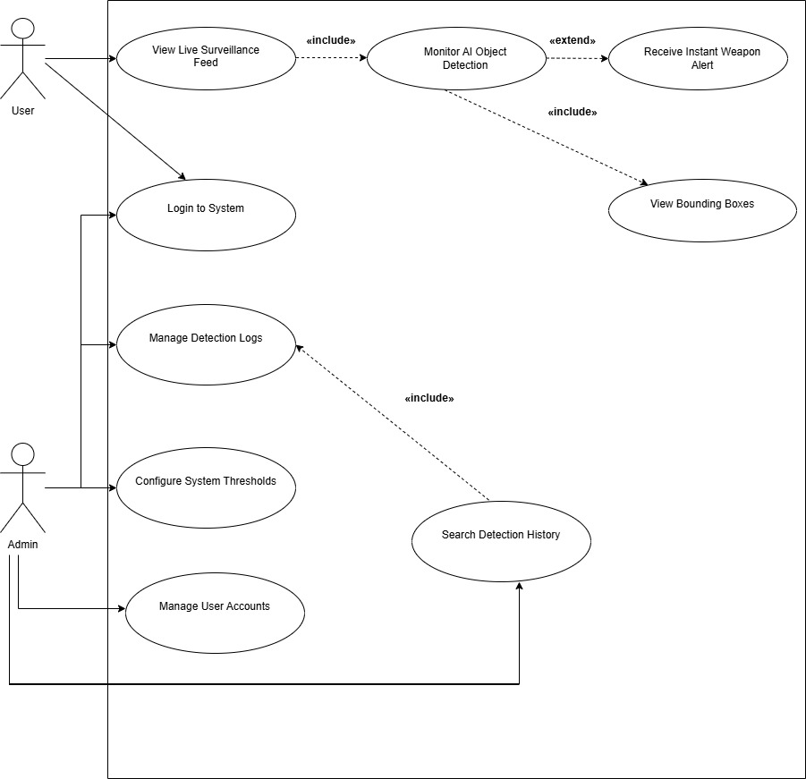

Figure 3.2.1 Use Case Diagram
3.2.2 Detailed Use Cases:

3.2.2.1 Use Case 1: User Registration

Field | Details
Use Case ID | UC-1
Use Case Name | Create Account
Actors | New User
Description | When you want to make an account this thing helps you do that. You can sign up by giving a username and password.
Pre-condition | First you need to have the application open on the screen that says Register.
Post-condition | After you do all the steps you will have a brand user account that is now, in the database.
Normal Flow | 1. User enters a unique username.  2. User enters a secure password.  3. User clicks on "Create Account" button.  4. System saves data and confirms registration.
Alternative Flow | If you already have an account you can switch to the "Sign In" tab. The "Sign In" tab is for people who already have an account, with us. You will find the "Sign In" tab there so you can switch to it and sign in to your account.
Exceptions | 1. Username already exists: System shows an error.  2. Empty fields: System prompts to fill all details.
Business Rules | Usernames must be unique.
Assumptions | User provides valid information.

3.2.2.2 Use Case 2: User Sign In

Field | Details
Use Case ID | UC-2
Use Case Name | User Sign In
Actors | Registered User / Admin
Description | Authenticates the user to grant access to the system dashboard.
Pre-condition | The user needs to have an account.
Post-condition | After that the user will go to the Threat Detection Core dashboard.
Normal Flow | 1. User enters username and password.  2. User clicks "Sign In".  3. System validates credentials.  4. Dashboard screen is displayed.
Alternative Flow | Not Available.
Exceptions | Invalid credentials. The system shows "username or password".
Business Rules | Minimum password length must be followed.
Assumptions | Authentication server is active.

3.2.2.3 Use Case 3: Video Upload & Processing

Field | Details
Use Case ID | UC-3
Use Case Name | Start Live Detection
Actors | User / Admin
Description | Uploading a thermal video file for real-time weapon signature tracking.
Pre-condition | User is logged in and system is in "Standby" mode.
Post-condition | Video is uploaded and the detection engine starts processing.
Normal Flow | 1. User clicks "Drop video or tap to upload".  2. User selects a file.  3. User clicks "Start Detection" button.  4. System begins analysis.
Alternative Flow | Not Available
Exceptions | 1. File size too large.  2. Unsupported video format.
Business Rules | Only supported formats are allowed.
Assumptions | Video file is not corrupted.

3.2.2.4 Use Case 4: Real-time Alert Monitoring

Field | Details
Use Case ID | UC-4
Use Case Name | Monitor Threat Alerts
Actors | User / Admin
Description | Viewing real-time alerts and snapshots of detected weapons.
Pre-condition | Detection session is active.
Post-condition | Alerts are displayed in the gallery with confidence scores.
Normal Flow | 1. System detects a weapon signature.  2. Snapshot is captured.  3. Alert is added to the list with class name (e.g., GUN) and confidence (e.g., 31%).
Alternative Flow | User can click "Clear All" to remove current session alerts.
Exceptions | AI model fails to identify signature due to low quality.
Business Rules | Every detection must show a probability percentage.
Assumptions | The YOLO model is loaded and running correctly.

3.2.2.5 Use Case 5: Review Session History:

Field | Details
Use Case ID | UC-5
Use Case Name | View Session History
Actors | User / Admin
Description | Accessing the database to review logs of previous monitoring sessions.
Pre-condition | User navigates to the "History" tab.
Post-condition | A list of past sessions with timestamps and detection counts is shown.
Normal Flow | 1. User clicks on "History" icon.  2. System fetches logs.  3. User reviews video names and date/time of completion.
Alternative Flow | User clicks the "Trash" icon to delete a specific record.
Exceptions | Database connection error.
Business Rules | Logs are sorted by most recent date.
Assumptions | Data was saved correctly in previous sessions.

3.2.2.6 Use Case 6: System Configuration

Field | Details
Use Case ID | UC-6
Use Case Name | Manage Settings
Actors | Admin
Description | Adjusting AI parameters like confidence threshold and FPS sampling.
Pre-condition | User navigates to the "Settings" tab.
Post-condition | New system configurations are saved and applied.
Normal Flow | 1. Admin adjusts "Confidence Threshold" slider.  2. Admin sets "FPS Sampled" rate.  3. Admin toggles "Alert Sound".  4. Admin clicks "Save Settings".
Alternative Flow | Admin clicks "Reload" to re-initialize the model.
Exceptions | Changes not saved due to system lag.
Business Rules | Settings apply to all future detection sessions.
Assumptions | Admin understands the impact of threshold levels.

3.2.2.7 Use Case 7: Logout & Session Termination

Field | Details
Use Case ID | UC-7
Use Case Name | Logout
Actors | User / Admin
Description | Safely closing the current session and returning to the login screen.
Normal Flow | 1. User clicks on the profile/email icon.  2. User selects "Logout".  3. System clears session data and redirects to Sign In page.

3.2.2.8 Use Case 8: Delete History Record

Field | Details
Use Case ID | UC-8
Use Case Name | Delete Session Record
Actors | User / Admin
Description | Removing a specific detection record from the session history.
Normal Flow | 1. User navigates to History.  2. User clicks the trash icon next to a video.  3. System asks for confirmation.  4. Record is removed from the database.

3.2.3 Event-Response Table:
The following Event-Response table describes the real-time behavioral logic of the Vision Guard system, detailing how specific operational events trigger backend AI processing and corresponding frontend system reactions.

Table4: Event-Response Table for “Vision Guard”
Event | System State | Response
User clicks "Start Detection" button. | Video is uploaded; Model is in "Loaded" state. | 1. Initialize YOLOv11 engine.  2. Start frame-by-frame analysis.  3. Update status to "Detecting".
AI Model detects a weapon signature. | Detection engine is active; Confidence > Threshold. | 1. Trigger auditory alert sound.
Weapon detection confidence is below Threshold. | Detection engine is active. | 1. Ignore the signature.  2. Do not trigger alert.  3. Continue monitoring next frame.
Detection session finishes or user clicks "Stop". | System is in "Detecting" state. | 1. Terminate AI processing.  2. Save session summary (total detections, timestamp) to DB.
User adjusts "Confidence Threshold" slider. | System is in "Settings" menu. | 1. Update internal variable for sensitivity.  2. Apply new threshold to the session.
User clicks "Reload" model button. | Settings tab is active; Model might be idle or error state. | 1. Re-initialize neural network weights.  2. Verify model status.  3. Display "Loaded" confirmation.
User clicks "Delete" (Bin) icon in History. | History tab is active. | 1. Locate record ID.  2. Permanently remove session entry.  3. Refresh History list on UI.
User enters invalid login credentials. | Sign-In screen is active. | 1. Verify against database.  2. Display "Invalid username or password" error.  3. Clear password field.

3.3 Functional Requirements:
This section describes the functional requirements of the system. Focusing on the core capabilities of the "Vision Guard" project. The primary function of the system is to provide a reliable method for detecting concealed weapons, such as handguns and knives, by processing real-time thermal imaging data through the YOLOv11 model. The system is designed to automatically identify heat signatures that indicate hidden threats, providing pixel-level visual feedback to security personnel. Additionally, the functional scope includes an automated alerting mechanism that triggers and gives warnings upon detection, as well as a secure logging system to store incident data for future review. These requirements ensure that the software transitions from simple monitoring to a proactive security framework that can operate effectively in high-traffic checkpoints and restricted zones.

3.3.1 FR-1 Real-Time Hidden Weapon Detection:

Table 5: Description of FR-1
Attribute | Description
Identifier | FR-1
Title | Real-Time Hidden Weapon Detection
Requirement | Upon receiving the pre-processed thermal frame, the system shall utilize the YOLOv11 model to identify and isolate hidden weapon signatures (handguns and knives) with pixel-level accuracy.
Source | Project Proposal – Module 2 (Detection Engine)
Rationale | This is the main part of the project because it helps find weapons hidden under clothes that we cannot see with our eyes. It makes security faster and safer because we don’t have to touch or search everyone manually.
Business Rule | The system must show the shape of the weapon found on the screen. This helps security staff quickly see if it is a threat or just something normal, like a phone. They need to tell the difference so they can take action. The system should highlight the weapons shape clearly on the screen. Security staff should be able to see if it's a gun or just a bunch of keys. This way they can react quickly. Stay safe.
Dependencies | None
Priority | High

3.3.2 FR-2 Thermal Image Pre-processing:

Table 6: Description of FR-2
Attribute | Description
Identifier | FR-2
Title | Thermal Image Pre-processing
Requirement | The system shall automatically normalize raw thermal input and apply contrast enhancement filters to maximize the visual difference between metallic objects and human thermal signatures.
Source | Project Proposal – Module 1 (Pre-processing)
Rationale | To ensure the AI model receives high-quality and consistent input, which directly increases the detection accuracy of concealed items.
Business Rule | The pre-processing cycle must be completed within 30 milliseconds to ensure a lag-free real-time monitoring experience.
Dependencies | None
Priority | High

3.3.3 FR-3 Real-Time Auditory and Visual Alerts:

Table 7: Description of FR-3
Attribute | Description
Identifier | FR-3
Title | Real-Time Auditory and Visual Alerts
Requirement | Whenever a concealed weapon is detected with a confidence score exceeding the threshold, the system shall trigger a visual warning on the dashboard and sound an auditory siren.
Source | Project Proposal – Module 3 (Alerts)
Rationale | To provide immediate notification to security personnel, allowing them to intercept potential threats without delay.
Business Rule | The alert response time (from detection to notification) must not exceed 2 seconds.
Dependencies | FR-1
Priority | High

3.3.4 FR-4 Secure Detection Event Logging:

Table 8: Description of FR-4
Attribute | Description
Identifier | FR-4
Title | Secure Detection Event Logging
Requirement | The system shall automatically record each detection event in the database, capturing a snapshot of the frame, weapon type, confidence level, and a precise timestamp.
Source | Project Proposal – Module 4 (History Log)
Rationale | This requirement provides a digital audit trail that is essential for forensic investigations and reviewing security performance.
Business Rule | Every detection above the 50% confidence threshold must be logged; logs must be read-only for standard users.
Dependencies | FR-1
Priority | Medium

3.3.5 FR-5 Detection Sensitivity Configuration:

Table 9: Description of FR-5
Attribute | Description
Identifier | FR-5
Title | Detection Sensitivity Configuration
Requirement | The Administrator will be able to change the detection confidence threshold, which is a number between 0.1 and 1.0 using the settings panel. This way the Administrator can make the system work better in environments. The Administrator can use the settings panel to adjust the detection confidence threshold to get the results, for the system in these environments.
Source | Project Proposal – Module 6 (Configuration)
Rationale | The system can be adjusted to reduce positives when it is being used a lot or when it is in a place with a lot of heat. The main reason for this is to make sure the system works well in these kinds of situations.
Business Rule | Business rule is that only people with Admin privileges are allowed to change these settings. These people are the ones who can make changes to the system settings. All of the changes that are made have to be written down in the system audit trail so we can keep track of what's happening to the system settings. Only users, with 'Admin' privileges can do this. It is very important that we keep a record of all the changes that are made to the system settings.
Dependencies | FR-1
Priority | Medium

3.3.6 FR-6 Role-Based User Access Control:

Table 10: Description of FR-6
Attribute | Description
Identifier | FR-6
Title | Role-Based User Access Control
Requirement | The system must have a login system. This will help the Security Guard to watch feeds. The Administrator will be able to manage logs and system settings.
Source | Project Proposal – Module 5 (User Management)
Rationale | We need to make sure the system is safe. This will stop people from accessing security information or technical settings without permission.
Business Rule | The system will close sessions if they are not used for 30 minutes. This helps to keep the system secure.
Dependencies | None
Priority | Medium

3.4 Non-Functional Requirements:
This section describes the quality attributes and performance standards of the “Vision Guard” system. While functional requirements focus on "what" the system does, these non-functional requirements define "how" the system should perform to be effective in a real-world security environment. For this project, the focus is on ensuring high reliability, system speed, and accuracy to provide dependable hidden weapon detection. These requirements are specified to be verifiable and measurable, ensuring that the software remains stable under continuous thermal monitoring, protects user data, and remains easy for security guards to operate without extensive technical training.

3.4.1 Reliability:
NFR-R1: The system shall maintain a Mean Time Between Failures (MTBF) of at least 15 days under continuous 24/7 thermal monitoring operations.
NFR-R2: In the event of a system crash or power interruption, the software shall automatically recover and resume the live thermal stream and detection services within 30 seconds of a restart.
NFR-R3: The system shall maintain an internal error log to record any communication failures between the thermal sensor hardware and the detection engine.
NFR-R4: The detection engine shall maintain at least 80% accuracy in identifying weapons concealed under standard clothing layers (such as jackets or shirts).

3.4.2 Usability:
NFR-U1: The dashboard shall be intuitive enough for security personnel to monitor feeds and understand segmentation masks with less than 30 minutes of initial training.
NFR-U2: The interface shall allow the user to toggle between "Raw Thermal Feed" and "Overlay Detection Mode" with a single click or tap.
NFR-U3: The User Interface should use colours that are easy to see so that we can clearly view the thermal heat signatures on the screen no matter how bright or dark it is, in the room.
NFR-U4: The system will give us error messages that make sense like "Thermal Camera Disconnected" and it will also tell us what to do to fix the problem.

3.4.3 Performance:
NFR-P1: The system shall process each thermal frame and generate pixel-level segmentation masks within a latency period of no more than 500 milliseconds.
NFR-P2: Alerts must be triggered within 1.5 seconds of a hidden weapon being identified by the YOLOv11-s model.
NFR-P3: Our system will make sure to store data in a way that thirty days worth of detection logs take up no than ten gigabytes of space on the local storage.
NFR-P4: The detection engine needs to work at a pace of fifteen to twenty frames per second. This way we can ensure real-time monitoring without any lag.

3.4.4 Security:
NFR-S1: We will use role-based access control. This means authorized administrators can change detection sensitivity levels or delete incident history.
NFR-S2: All thermal snapshots and sensitive detection logs will be stored in a directory. We will encrypt this directory to prevent people from accessing the data without permission.
NFR-S3: If a user is inactive, for twenty minutes the system will automatically end their session. This helps prevent users from accessing the security dashboard.
NFR-S4: Every time someone tries to access restricted settings or export sensitive security logs we will record it. This record will include the users ID and the time of the attempt. It will be stored in an audit trail that cannot be changed.

3.5 External Interface Requirements:
This section describes how the “Vision Guard” system interacts with its users, the specialized thermal imaging hardware, and the underlying software frameworks. It makes sure the camera and the YOLOv11 detection engine work well together. This allows data to flow in time and sends immediate alerts to security teams. The interfaces make sure that thermal signatures are captured, processed and shown as images, to security personnel. They see the signatures as clear segmentation masks.

3.5.1 User Interface Requirements:
The user interface (UI) for “Vision Guard” is designed to be simple and easy to use for security guards. Since the system uses thermal imaging to find hidden weapons, the screen needs to be very clear so that any threat can be seen immediately.
• Design Consistency:
- The application shall maintain a consistent layout across all screens to ensure that users do not get confused when navigating through different modules.
- Standardized icons and clear labels shall be used for all system functions.
• Thermal Feed Display:
- The main interface shall feature a large viewport dedicated to the live thermal stream, ensuring the operator has a clear view of the area being monitored.
- The system shall allow the user to switch between different thermal visualization modes to suit different lighting and environmental conditions.
- Any detected hidden threats shall be highlighted with a clear visual overlay that follows the exact shape of the object.
• Screen Layout and Organization:
- The dashboard shall be organized into logical sections: a primary monitoring area, an alert notification panel, and a navigation menu.
- The interface shall be optimized for standard high-resolution monitors to ensure all text and data are legible from a reasonable distance.
• Navigation and Control:
- Key functions such as "Live Stream," "Incident History," and "User Settings" shall be accessible via a persistent navigation bar.
- The UI shall include a "Snapshot" feature to allow the operator to capture and inspect a specific moment in the feed.
• Alerting and Messaging:
- When a threat is identified, the system shall display a high-priority visual alert on the screen that remains visible until the user acknowledges it.
- Standardized status messages shall be displayed to inform the user about the system’s health, such as camera connectivity and AI model status.
- Confirmation dialogs shall appear before any major action, such as deleting history logs or changing system-wide configurations.
• User Feedback and Interaction:
- The system shall provide immediate visual feedback whenever the user interacts with the interface.
- The interface shall show a "Confidence Level" next to any detected object to help the user make informed decisions.
• System Adjustments:
- The interface shall include input fields that allow authorized users to tune the detection sensitivity and alert thresholds easily.
- Users shall have the ability to toggle specific interface layers on or off, such as the timestamp, frame rate, or detection masks.

3.5.2 Software interfaces:
The “Vision Guard” system connects with different software tools and libraries to make sure the thermal detection works smoothly. These connections allow the system to process video, run the AI model, and save important data.
- SI-1: AI Detection Framework:
- SI-1.1: The system shall interface with the YOLOv11 model libraries to identify hidden weapons and create accurate segmentation masks on the thermal feed.
  - SI-1.2: The software shall communicate with deep learning libraries to handle the real-time calculations needed for weapon recognition.
- SI-2: Video Processing Library:
  - SI-2.1: The system shall use image processing libraries to capture the thermal video stream and prepare each frame for the AI model.
- SI-2.2: The software shall use these libraries to draw visual overlays, like detection shapes and labels, directly onto the live video feed.
- SI-3: Database System:
  - SI-3.1: The system shall connect to a local database engine to securely store history logs, including weapon types and detection times.
- SI-3.2: The system shall provide a way to search and pull old records from the database when a user wants to check the detection history.
- SI-4: System Graphics Interface:
  - SI-4.1: The application shall interface with the computer’s graphics drivers to ensure the thermal video displays smoothly without lagging.
- SI-5: Messaging and Alert Services:
  - SI-5.1: The system shall use standard email or messaging protocols to send instant alerts to security supervisors if a high-confidence threat is detected.

3.5.3 Hardware interfaces:
The system must interact with various hardware components to capture thermal data and provide alerts. The following requirements define how the software communicates with these physical devices:
- HI-1: Thermal Imaging Sensor (Camera)
  - HI-1.1: The software shall interface with a thermal imaging camera that is capable of detecting heat signatures through clothing.
- HI-1.2: The software shall use standard communication to ensure a steady flow of video frames at a minimum rate of 15 frames per second.
- HI-2: Computing Unit:
  - HI-2.1: The system shall interface with the graphics processing unit (GPU) of the computer to speed up the YOLOv11 AI calculations.
- HI-2.2: The software shall monitor the hardware’s CPU and RAM usage to ensure the system does not overheat or crash during long monitoring sessions.
- HI-3: Audio Output Device:
- HI-3.1: The software shall connect to the local sound system or internal speakers to play an auditory alarm whenever a hidden weapon is confirmed.
- HI-3.2: The system shall provide a hardware-level volume control interface so the alarm is loud enough to be heard in a busy security environment.
- HI-4: Display Monitor:
  - HI-4.1: The software shall interface with high-resolution monitors to display the live thermal feed and the segmentation overlays clearly.
- HI-4.2: The system shall detect the monitor's aspect ratio and automatically adjust the thermal video feed to prevent the image from looking stretched or distorted.
- HI-5: Storage Hardware:
- HI-5.1: The system shall interface with the internal Hard Drive or SSD to write and read large video files and detection snapshots without slowing down the live analysis.

3.5.4 Communications interfaces:
The system requires reliable communication channels to transfer thermal video data and to send out emergency alerts to the relevant authorities. The system needs to use TCP/IP protocols so that thermal data packets are delivered correctly from the camera to the processing unit without losing any data. The system has to use these protocols to make sure the data gets to where it needs to go.
- CI-1: Network Transfer Protocols:
- CI-1.1: It is about using standard TCP/IP protocols for thermal data packets, from the camera to the processing unit.
- CI-1.2: is important too: when the camera is connected to a network the system has to use RTSP to keep the video stream going and stay stable which is the Real-Time Streaming Protocol. This way the camera and the system work well together to keep the video stream stable.
- CI-2: Automated Alert Notifications:
  - CI-2.1: The system shall have the capability to send automated email alerts to the security supervisor’s account whenever a high-confidence threat is detected.
- CI-2.2: The software shall use a secure protocol to ensure that incident reports and snapshots are transmitted safely to authorized email addresses.
- CI-3: Web Browser Integration:
- CI-3.1: If you access the dashboard from a location the system should work with regular web browsers. This will let security personnel watch the feed from places.
  - CI-3.2: The system should encrypt the data sent between the server and the browser. This protects thermal video data from being intercepted by people who are not supposed to see it.
- CI-4: Local Network Communication:
  - CI-4.1: The system shall communicate with local network printers or shared drives if the administrator chooses to export or print an incident report.
- CI-4.2: The software shall be able to ping the thermal hardware regularly to check the connection status and alert the user if the network link is broken.
- CI-5: Data Formatting for Reports:
- CI-5.1: All communication of detection data (like time, date, and weapon type) shall be formatted in a standard way so it can be easily read by other security management software if needed.

Chapter 4

Design and Architecture
The Design and Architecture chapter serves as the structural blueprint for the “Vision Guard” system. While the previous chapters focused on what the system should do, this section explains how it will be built. For a system that detects heat the design must manage jobs. These jobs include getting data in time from heat sensors. The system must also process this data fast using the YOLOv11 model. Then it must show the results away. This part explains the parts of the system. It also describes how data moves between the AI part and the user interface. The design is modular. This makes the system able to grow and be trusted for security work. The system must handle real-time data from sensors. It uses the YOLOv11 model for processing. The results are segmentation masks from sensors. The system is designed for security monitoring, with thermal sensors.

4.1 Architectural Design:
The way “Vision Guard” is built is really simple. It has lots of parts that work together. Each big part does its job and is like a separate box. This makes the whole system easy to change and fix when we need to. We broke down Vision Guard into pieces, like the part you see the part that does the work the part that finds things and the part that stores information. These pieces talk to each other in a way: something comes in we find what we are looking for and then we get an answer. The primary design principle is the separation of concerns. This decomposition ensures system parts can be developed, tested, and scaled independently, making the system robust and efficient. The main purpose here is to show how the system was decomposed and how the individual parts work together to achieve the static image processing functionality.

High-Level Functional Flow
- User provides image input to the UI Layer.
- The Processing Layer gets the input. Sends the image to the Detection Layer. The Image Pre-processing Module helps prepare the image for the model.
- The YOLOv11 Detection Engine analyzes the processed image in the Detection Layer.
- The result returns to the Processing Layer. The Alert Module triggers warnings/logging indicators based on the detection confidence.
- The Detection Log Module stores the result in the Data Layer.
- The user can review past detections through the UI Layer.
This breakdown makes sure that each part of the system does one thing, which makes the whole system easier to test and change. The decomposition helps to keep things so when something goes wrong it is easier to find the problem. The system is also easier to modify because each part of the system only does one thing, like the decomposition.

4.1.1 Initial Design Stage: Box and Line Diagram:
This diagram provides a high-level, simple representation of the four major subsystems and illustrates their synchronous connections for the current Static Image Processing functionality.

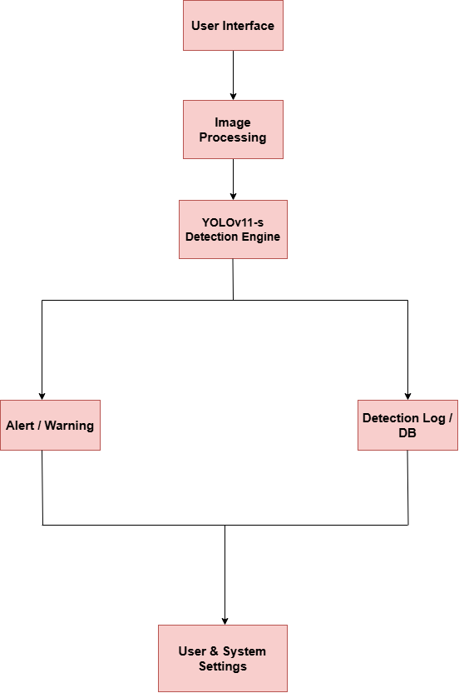
Figure 4.1.1 Box and Line Diagram

4.1.2 Architectural Mapping: Multi-Tiered Structure
The logical modules are mapped directly onto the Multi-Tiered Architecture pattern. This detailed structure clarifies the physical and logical dependencies between the Presentation, Application, specialized AI Compute, and Data Tiers.
1. Presentation Layer (Frontend):
The parts of the system that deal with user interaction are found here. This part is in charge of how the user experience feels what the user types in and what the user sees and it all happens in the users web browser. It has things, like the Authentication forms, where the user can Sign Up or Sign In to get into their account. The Navigation Bar is also here. It helps the user get around the system. Then there is the Image Upload Interface, where the user can send in picture files to be looked at. The Image Upload Interface is important because it is where the user can submit the picture files for the system to detect things in the images. The user can use the Image Upload Interface to send in image files.
2. Application Logic Layer (Backend):
This layer is, like the brain of the system. It lives on the Application Server. It helps run all the business logic. This layer has a part called the Authentication Manager. The Authentication Manager checks if user credentials are valid. The API Router receives validated user requests, applies the system's flow control, and securely forwards the image data across the network to the dedicated AI Compute Tier. Upon receiving the result, the Alert Module/Business Rules Engine executes the logging criteria, and the Log Data Writer component prepares the final audit record before sending it to the Data Tier. This layer ensures all actions adhere to security and logic protocols.

3. AI and Analytics Layer:

This layer is specialized and physically isolated on a server to handle the high computational demands of the deep learning model. Its primary function is image analysis and feature extraction. Components here include the YOLOv11 Inference Core. The Image Pre-processing module prepares the image tensor for the model, while the Mask Encoding Utility efficiently compresses the raw pixel-level output into a compact JSON format suitable for network transmission back to the Application Tier, minimizing latency.

4. Data Access Layer:

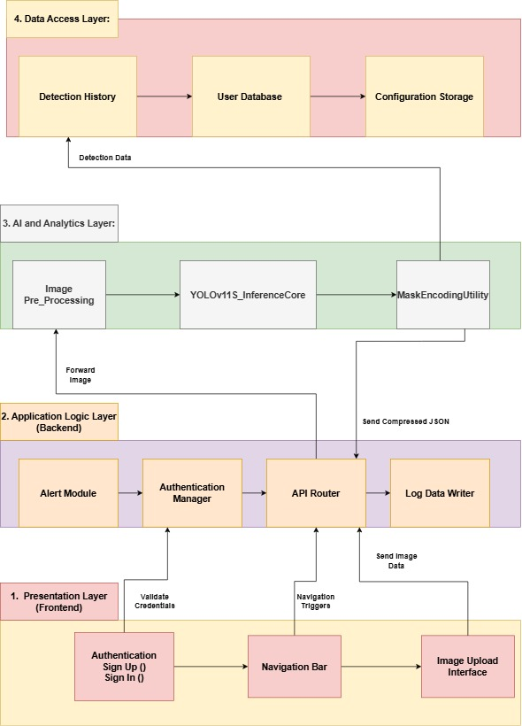
This foundational layer ensures data persistence and integrity for the entire system, containing all required databases. It stores the User Database (hashed credentials and roles) and essential Configuration Storage (like detection thresholds). Most importantly, it holds the complete Detection History/Audit Log, which securely archives every processed event's metadata and the crucial segmentation mask JSON, making all detections auditable and verifiable. This layer is accessed exclusively by the Application Tier via dedicated database drivers.

Figure 4.1.2 Component-based Layered Architecture

4.2 Design Models:

4.2.1 Activity Diagram:
4.2.1.1 Live Detection & Monitoring:

The system is always looking at pictures that come in through the web page. When it finds a weapon it puts a mark around it so people can see it right away. This happens in time so the staff gets to see what is going on immediately. The system uses something called YOLOv11 to help it find these hidden weapons. It puts a box around them.

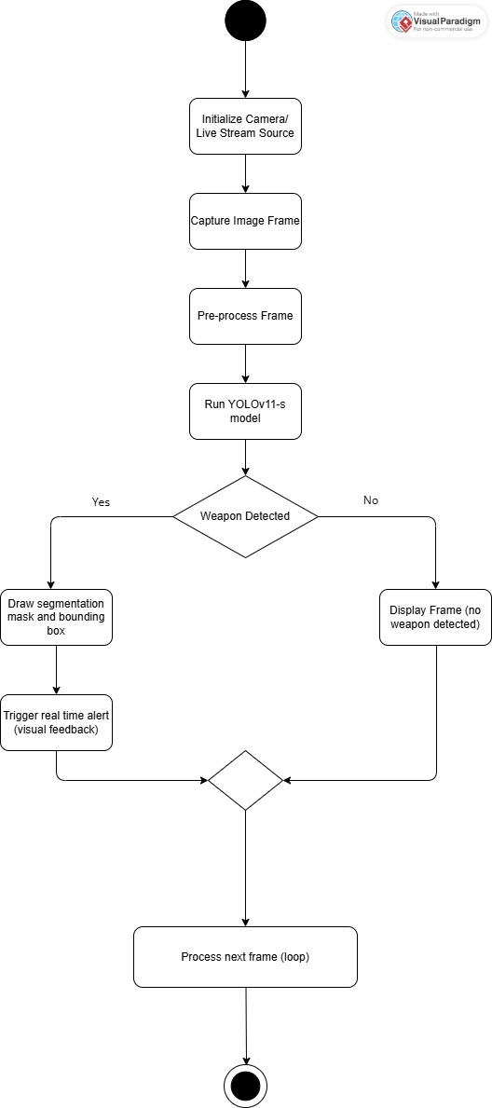

Figure 4.2.1.1 Live Detection & Monitoring:

4.2.1.2. Alert Notification System:

The system is always looking at pictures that come in through the web page. It checks these pictures for weapons. When the system finds a weapon it puts a mark around the weapon so people can see the weapon away. This happens in time so the staff gets to see what is going on with the pictures immediately. The system uses YOLOv11 to help it find these weapons. The system puts a box around the weapons it finds.

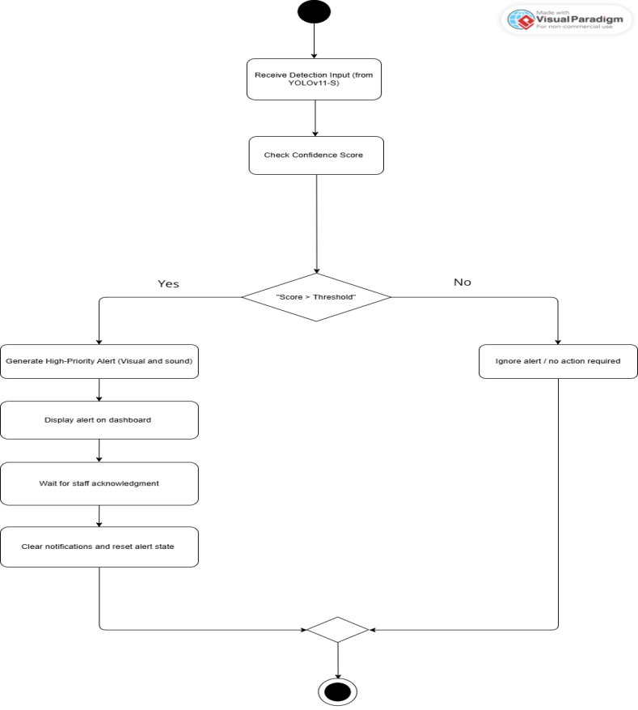

Figure4.2.1.2. Alert Notification System

4.2.1.3. Security Dashboard Monitoring:

The central use case that allows staff to view the aggregate status of all cameras (online/offline), see the incoming alert feed, and manage the active monitoring session from a single responsive web interface.
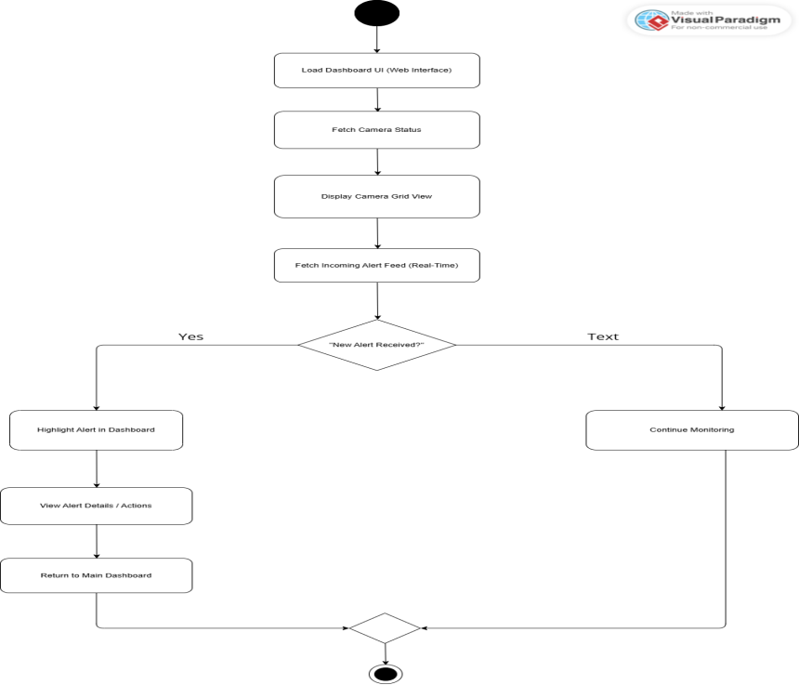

Figure 4.2.13 Security Dashboard Monitoring
4.2.1.4 Data Training and Model Updates:

This is for the Administrator to use. The Administrator uses this function to take care of the AI core. It is where the Administrator uploads pictures that have notes on them starts the process to train the YOLOv11 model again and then puts the new trained model into the production environment where it can be used. The Administrator is, in charge of the AI core. This function helps the Administrator do that job.

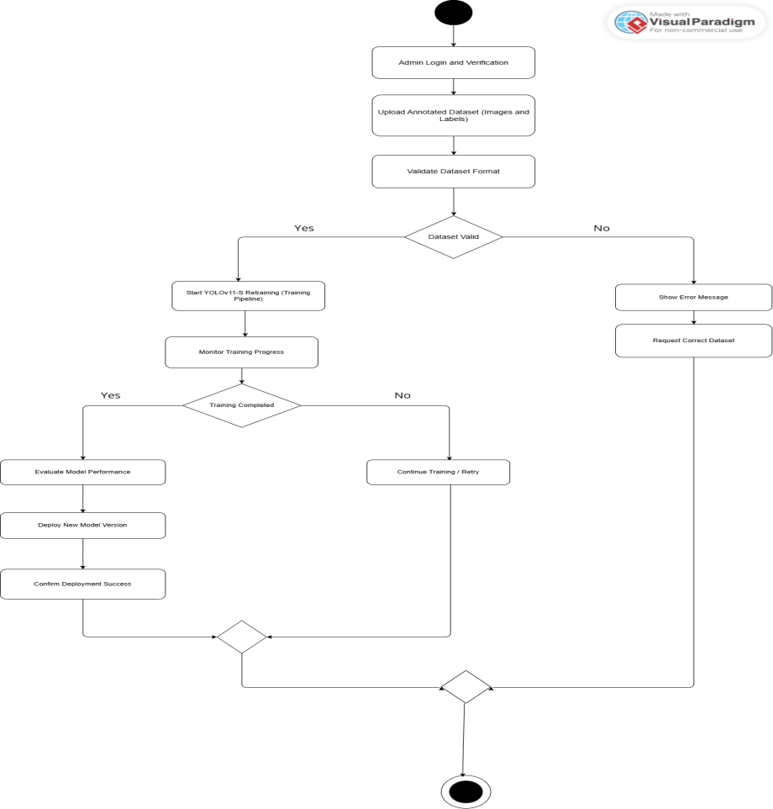

Figure4.2.1.4 Data Training & Model Updates

4.2.1.5. System Configuration and Admin:

Allows the Administrator to manage the System Configuration entity, including setting the detection confidence threshold, configuring camera metadata, and managing user roles/permissions via dedicated web forms.

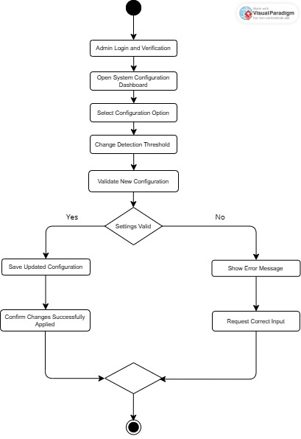

Figure 4.2.1.5 System Configuration and Admin

4.2.1.6. Review Detection History:

Enables users to query and filter the Detection-Log data store (based on date, camera, or weapon type). The system retrieves past events, allowing the user to view the stored segmentation mask image and export summary reports for audit compliance.

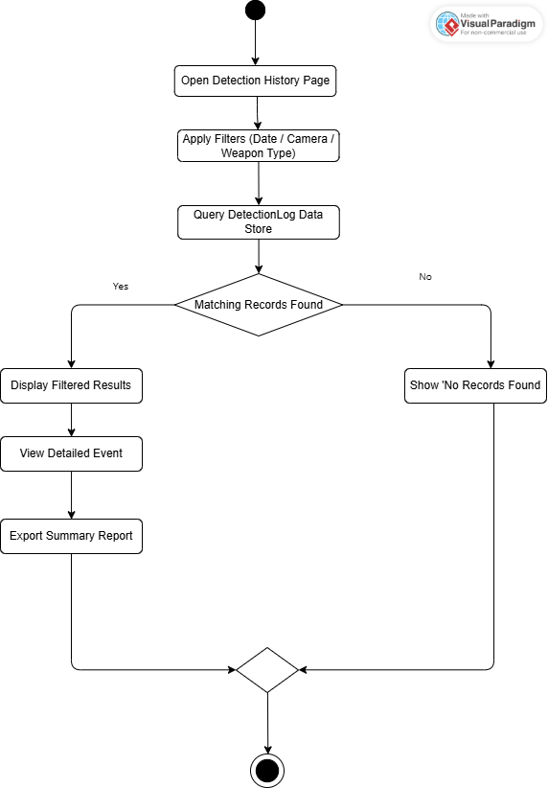

Figure 4.2.1.6 Review Detection History
4.2.1.7 User Authentication & Session Management:

A fundamental web security use case. It covers Sign-In (Login) to validate credentials against the User-Account entity and Sign-Out (Logout) to securely terminate the user's web session token to protect the sensitive dashboard access.

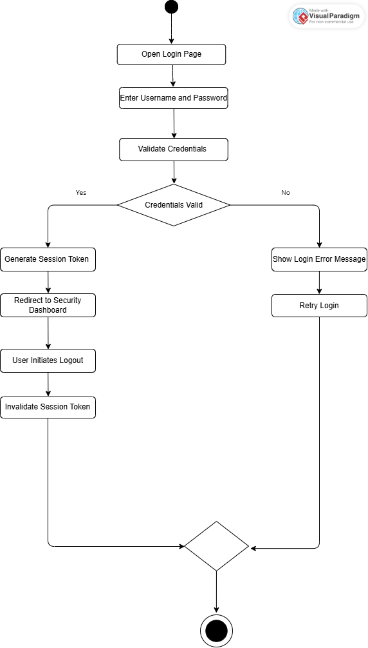

Figure 4.2.1.7 User Authentication & Session Management

4.2.2 Class Diagram:

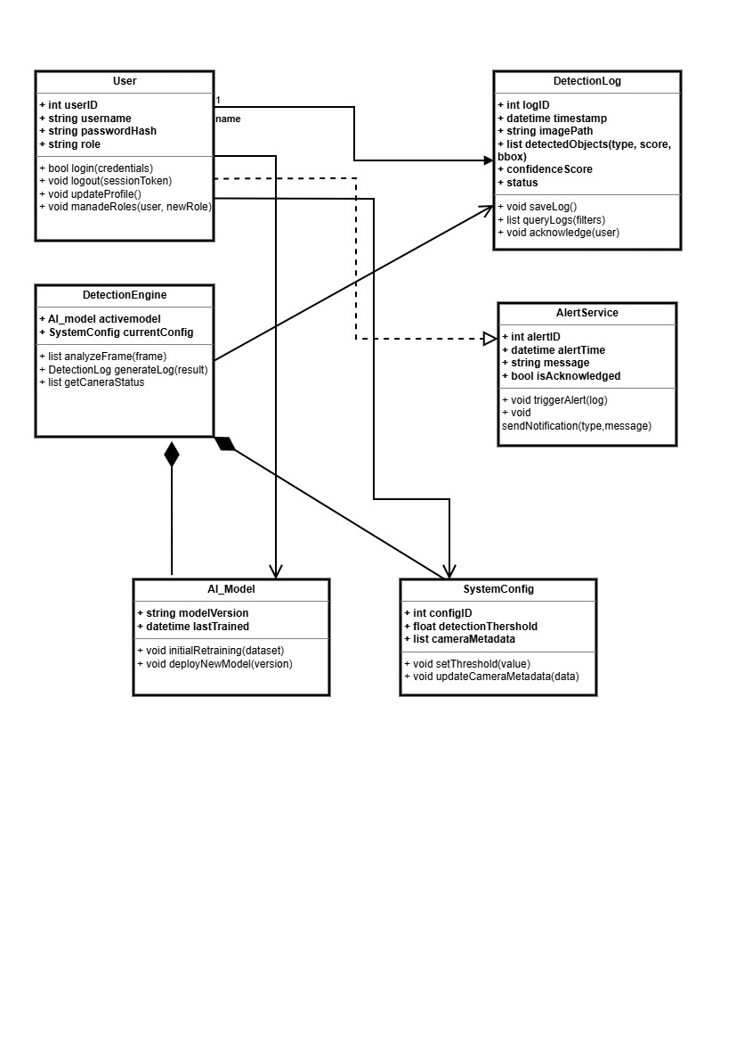

Figure 4.2.2 Class Diagram
Explanation:
The Class Diagram for the “Vision Guard” system explains how different parts of the software work together to detect weapons. At the center is the User Class, which handles the login and registration process for guards or admins. When a user uploads a thermal video, the Video Class takes over to manage the file and break it down into frames. These frames are then sent to the Detection Engine Class, which is basically the brain of the system. The Detection Engine Class uses the AI model to look at each frame for weapon signatures. It does this based on the confidence settings. If the AI model finds something that it thinks is a threat it tells the Alert Class. The Alert Class is in charge of showing a message on the screen and making a noise to warn the user. The Detection Engine Class and the Alert Class work together to make sure the user knows what is going on. The Session History Class gets all the details about what was found like what time it happened and what the AI model saw. The Session History Class saves all of this information in a database. This way the user can look back at what happened or get rid of old records. The Detection Engine Class and the Session History Class are parts of the system.
This diagram shows what happens from the time the user logs in to the time a security alert is saved. It is a process. The user logs in. The system starts working. The system looks at each frame. Checks, for threats. If it finds a threat it warns the user. Then it saves all the details. The Detection Engine Class and the Session History Class make sure everything runs smoothly.

4.2.3 System Sequence Diagrams:
4.2.3.1 Live Detection & Monitoring:

The system is always looking at pictures that come in through the web page. When it finds a weapon it puts a mark around it so people can see it right away. This happens in time so the staff gets to see what is going on immediately. The system uses something called YOLOv11 to help it find these hidden weapons. It puts a box around them.

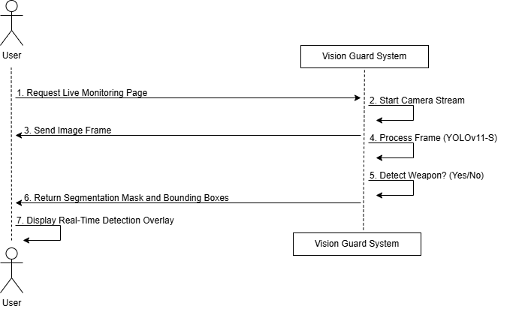

Figure 4.2.3.1 Live Detection and Monitoring

4.2.3.2. Alert Notification System:

The system is always looking at pictures that come in through the web page. It checks these pictures for weapons. When the system finds a weapon it puts a mark around the weapon so people can see the weapon away. This happens in time so the staff gets to see what is going on with the pictures immediately. The system uses YOLOv11 to help it find these weapons. The system puts a box around the weapons it finds.
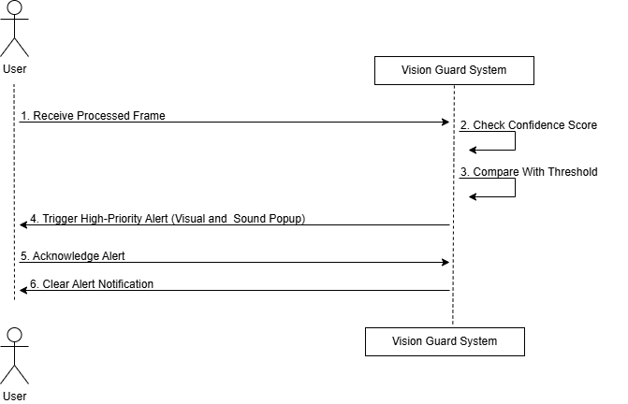

Figure 4.2.3.2 Alert Notification System

4.2.3.3. Security Dashboard Monitoring:

The central use case that allows staff to view the aggregate status of all cameras (online/offline), see the incoming alert feed, and manage the active monitoring session from a single responsive web interface.

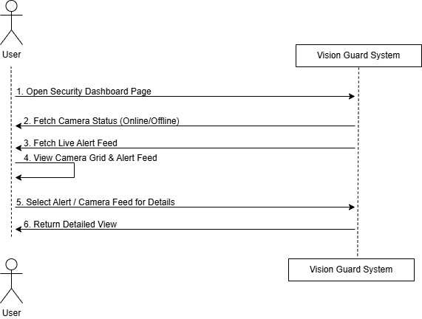

Figure 4.2.3.3 Security Dashboard Monitoring

4.2.3.4 Data Training & Model Updates:

This is for the Administrator to use. The Administrator uses this function to take care of the AI core. It is where the Administrator uploads pictures that have notes on them starts the process to train the YOLOv11 model again and then puts the new trained model into the production environment where it can be used. The Administrator is, in charge of the AI core. This function helps the Administrator do that job.
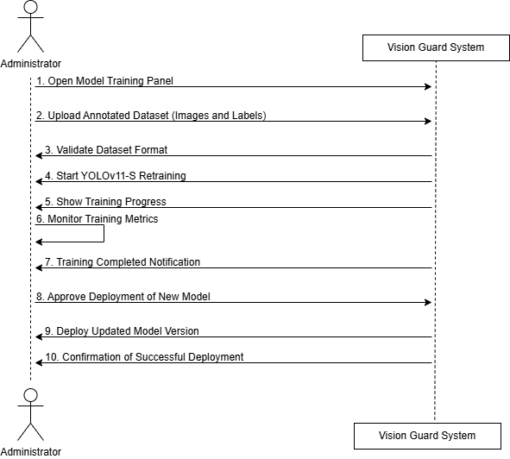

Figure 4.2.3.4 Data Training and Model Updates

4.2.3.5. System Configuration & Admin:

Allows the Administrator to manage the System Configuration entity, including setting the detection confidence threshold, configuring camera metadata, and managing user roles/permissions via dedicated web forms.
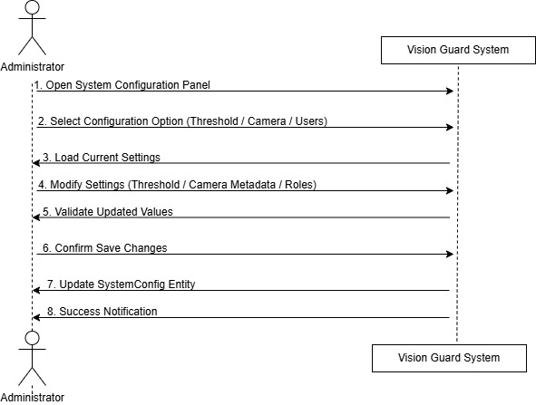

Figure 4.2.3.5 System Configuration and Admin

4.2.3.6. Review Detection History:

Enables users to query and filter the Detection-Log data store (based on date, camera, or weapon type). The system retrieves past events, allowing the user to view the stored segmentation mask image and export summary reports for audit compliance.

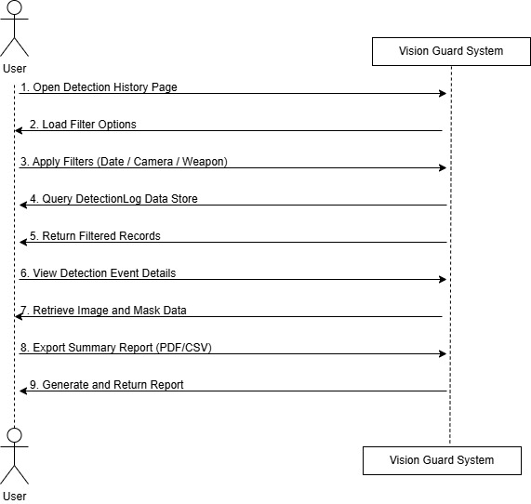

Figure 4.2.3.6 Review Detection History

4.2.3.7 User Authentication & Session Management:

A fundamental web security use case. It covers Sign-In (Login) to validate credentials against the User-Account entity and Sign-Out (Logout) to securely terminate the user's web session token to protect the sensitive dashboard access.

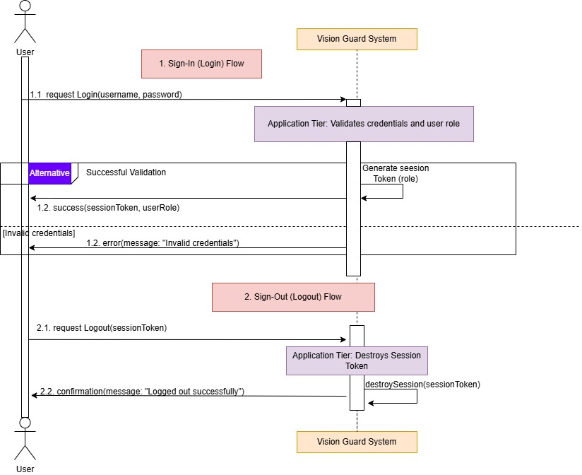

Figure 4.2.3.7 User Authentication and Session Management

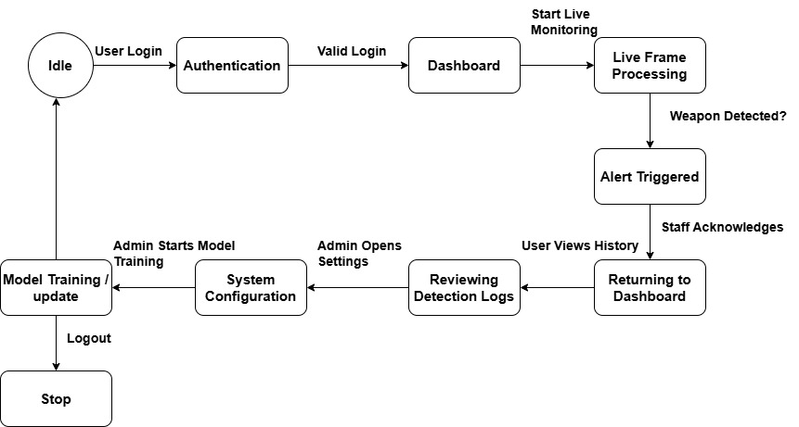
4.2.4 State Transition Diagram:
Figure4.2.4. State Transition Diagram

Explanation:
The State Transition Diagram for the Vision Guard system shows the stages the software goes through from the moment it starts. It begins in the Idle State waiting for a user to enter credentials. Once the user is authenticated it moves to the Dashboard State, where it waits for user input. When a user uploads a video and clicks start the system goes into the Detection State. In this state the AI scans for weapons. If a weapon is found the system immediately goes into the Alert State. It triggers alarms. Shows visual notifications. After detection is complete or stopped the system saves the session details in History. Then it returns to the Dashboard State. Goes back, to the Idle State.

4.3 Data Design
The Data Design section clarifies how the system's conceptual requirements, centered on secure access and the verifiable output of weapon segmentation, are structured for persistent storage. This process transforms the information domain into distinct data entities residing within the Data Layer. The design prioritizes the integrity and efficient storage of the core analytical output: the high-fidelity geometry data generated by the YOLOv11 model.

4.3.0.1 Information Domain Transformation:
The system's operational needs are converted into data structures based on the following principles:
- High-Fidelity Segmentation Storage:
The primary output of the AI is the segmentation mask, which is a complex array of coordinates defining a weapon's outline. This raw geometric data is transformed into a JSON data type within the database. This allows for flexible storage that retains the precision of the model's output, essential for accurate visualization and auditing.
- Auditability and Event Recording:
Every image analysis event is logged as an immutable record. This is materialized as the Detection-Log entity, which captures the transaction's metadata (time, confidence, classification) alongside the segmentation geometry. This entity is central to the system's accountability and history features.
- Security and Access Control:
User credentials and roles are changed into the User-Account entity. The system does this to keep everything. Passwords are not stored where people can easily read them. They are changed into a code that cannot be turned back into the original password. This is done to make sure the system is very secure. The system needs to control what users can do based on their roles. This is called Role-Based Access Control. The User-Account entity helps the system do this. User credentials and roles are very important for the User-Account entity to work properly.

4.3.0.2 Data Storage, Processing, and Organization:
- Storage Mechanism:
The system relies on a Primary Database. The selection is influenced by the need to efficiently handle and query the complex, variable-length JSON data that defines the segmentation masks.
- Processing:
Data transformation is managed by the Application Tier (Processing Layer). The Log Data Writer component is responsible for collecting the final result packet from the AI Compute Tier, structuring it according to the schema below, and committing the verified record to the database.
- Organization:
Data is organized into cohesive entities (UserAccount, DetectionLog, SystemConfig). The primary organization for the history is chronological within DetectionLog, which facilitates filtering and retrieval for the Security Staff's audit views.

4.3.0.3 Databases and Data Storage Items:
- Primary Database:
This is the mandatory, live data repository for the system. It securely stores all structured entities, including User-Account credentials, system configurations, and the complete Detection History/Audit Log. It is selected for its ability to efficiently manage and query the complex segmentation mask data, which is stored as a flexible JSON type.
- External File Storage:
This represents the planned, scalable solution to store the source image files themselves. While not strictly used to store results in the current static image phase, the Detection-Log entity will eventually reference the file's location (via path/URL) to ensure full historical context is available for every audit event.

4.3.1 Data Dictionary:
The following table provides an alphabetical listing of the major entities and data fields that structure the information domain of the Vision Guard system, along with their data types and descriptions. This schema supports the core functions of logging detections, managing users, and ensuring system auditability.
Table 11: Data Dictionary
Entity/Field Name | Data Type | Description | Notes / Constraints
alert_status | STRING | Indicates if the detection met the system's business rules for an alert. | Used by the Alert Module (e.g., 'High Priority', 'Logged').
bounding_box | JSON | The simple rectangular coordinates that we use are the x and y position and also the width and height of the detected weapon. | We use these coordinates of the detected weapon for things, like making the pictures look nice and fast or for looking at the detected weapon again.
confidence_score | FLOAT | The YOLOv11 model gives us a number that shows how sure it is about something. This number is between 0.0 and 1.0. The YOLOv11 model output is, like a score that says how certain the YOLOv11 model is.
DetectionLog | (Entity) | This thing keeps a record of everything that happens when it works on pictures. It stores the record of every time it processes an image. | Core system entity.
image_source_path | STRING | Path or reference (URL) to the source image file. | Ensures historical context and audibility.
log_id | UUID | Unique primary key identifier for the specific detection event. | Primary Key, Indexed.
password_hash | STRING | You need a password for a user that is protected with a lock. This is necessary. | The password lock has to be very strong like the kind that Bcrypt uses.
role | ENUM/STRING | User access level within the system. | Restricted to 'Administrator' or 'Security Staff'.
SystemConfig | (Entity) | Stores global operational parameters for system tuning.
config_key | STRING | You also need to give a name to the setting, for the configuration for example you can call it 'MIN_CONFIDENCE_THRESHOLD'. | Primary Key.
config_value | FLOAT/STRING | Value associated with the configuration setting. | Used by the Application Tier.
timestamp | DATETIME | The server time when the image analysis was completed.
UserAccount | (Entity) | Stores system user information for login and access control.
user_id | UUID | Unique primary key for the system user. | Primary Key.
username | STRING | Unique login identifier for the user. | Indexed, Unique.
weapon_type | STRING | The type of thing that the model finds, like a Handgun or a Knife.

4.4 Human Interface Design:
The Vision Guard system utilizes a secure, responsive web-based dashboard as its primary human interface, designed to facilitate immediate decision-making for the Security Staff and comprehensive control for the Administrator. The core of the interface is the Live Detection & Monitoring screen, which continuously displays camera feeds where the YOLOv11 model's output is visualized in real-time as a precise, color-coded segmentation mask and bounding box overlay, marking the detected weapon directly on the image frame. This visual feedback is paired with a high-priority, persistent auditory and visual Alert Notification panel that requires user acknowledgment, instantly diverting staff attention. Beyond real-time processing, the interface provides dedicated management areas for System Configuration and Detection History, allowing users to filter the audit log, retrieve and view the original segmented images, and securely manage access through the streamlined User Authentication forms.

4.4.1 Screen Images:
- User Registration Interface:

Description:

The registration screen is where new users can make an account. To do this they need to enter an username and password that are just, for them. When they click the button the system tells them away if everything is okay. It will say that the account is made or it will show an error if some information is missing or if someone else is already using the username they want. The registration screen is really important for new users to create an account.

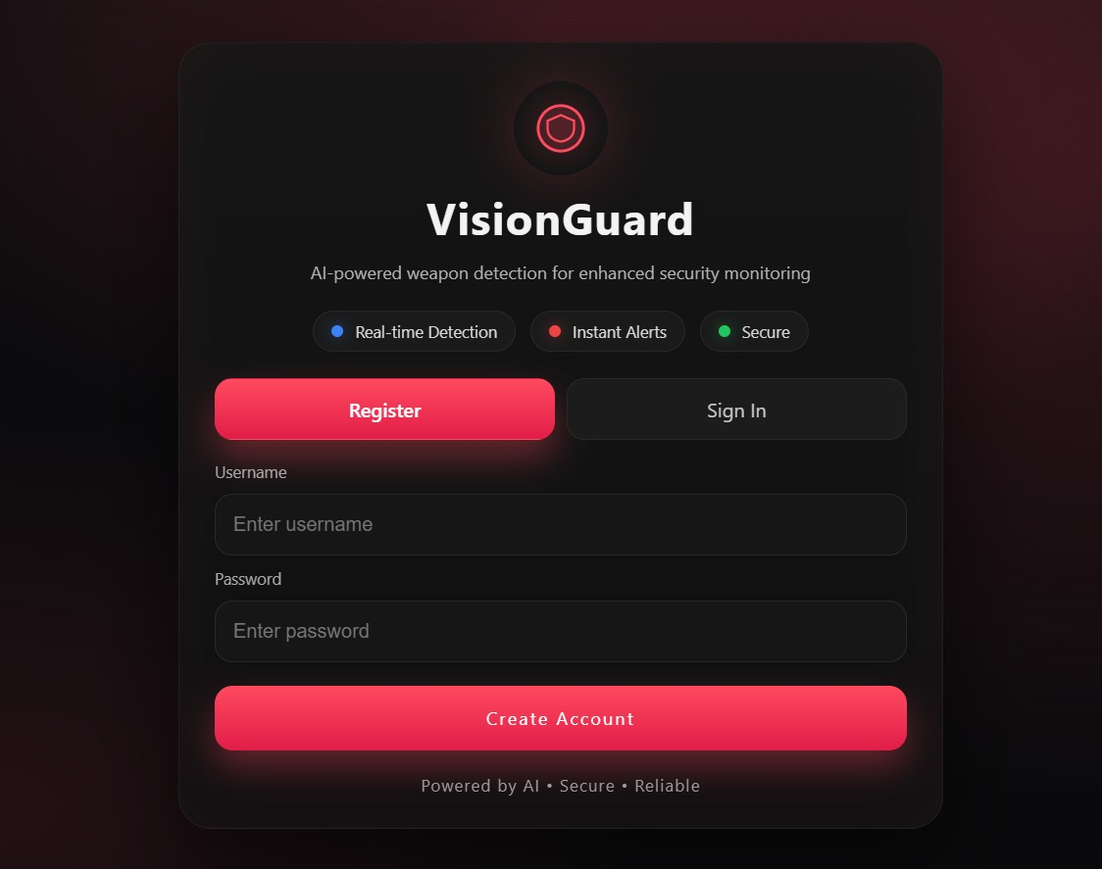

Figure 4.4.1 User Registration
- User Authentication Interface:

Description:

When you want to get into the system you have to go through the login screen. This is where the guards or the admins type in their username and password to get in. The system then checks these details against what it has in the database. If everything is okay it takes the guards or the admins to the dashboard.. If the details are not right it shows a warning message. The login screen is like a door that only opens if you have the correct login credentials. The system is very careful, about who it lets in. It checks the login credentials very carefully.

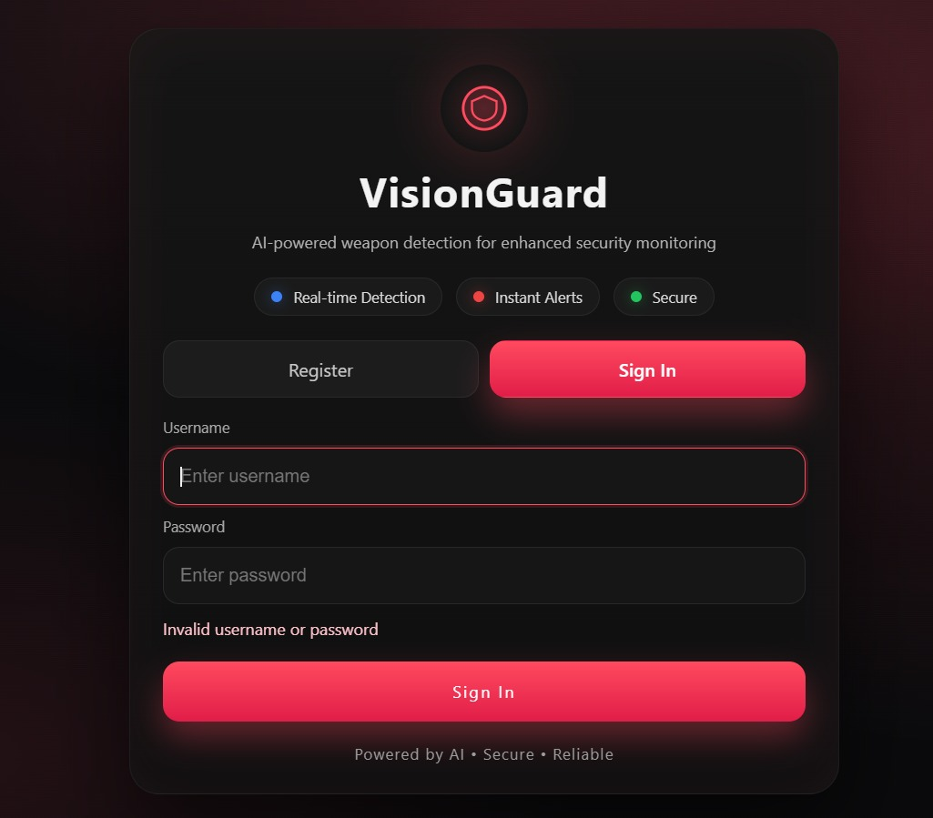
Figure 4.4.1 User Authentication Interface

4.4.2 Screen Objects and Actions:
Table 12: Screen Objects and Actions
Screen Object | Associated Actions | Screen
Email/Password | Enter Text: User inputs credentials. | Login Screen
"Sign In" Button | Click: Submits credentials to the server for authentication | Login Screen
Active Cameras List | View: Checks the connectivity and status of all cameras | Home Screen/Dashboard
Navigation Bar Links | Click: Navigates between Dashboard, Alert, History, and Settings screens. | Home Screen/Dashboard
Active Alert List Entry | View: Displays time, camera, location, and status of recent detections. | Alert Screen
"Reviewed" Checkbox/Button | Click: Acknowledges the specific alert, stopping the alarm and logging the action. | Alert Screen
Detection History Table Row | Click: Loads a detailed view of the specific historical event, including the original image and segmentation mask. | Detection History Screen
Alert Sound Toggle/Selector | Toggle/Select: Enables/disables or changes the auditory alarm profile. | Settings Screen
Login User Details Fields | Enter Text: Updates the user's email or password/ | Settings Screen
"Log Out" Option/Button | Click: Securely terminates the current user session. | Settings Screen

Chapter 5

Implementation
This chapter describes the practical realization of the “Vision Guard” system, focusing on how the conceptual designs were translated into a functional software solution. It outlines the technical environment, the integration of the YOLOv11 object detection model, and the systematic development of the core modules.

5.1 Algorithm:

5.1.1 Algorithm 1: Model Training Process

Algorithm 1: Model Training Process

Input:
- Dataset (weapon.v1i.yolov11.zip)
- Pre-trained Model (yolov11-model.pt)
- Epochs: 50
- Image Size: 640

Output:
- best.pt (best-performing model weights)
- last.pt (final model weights after training)

1. SET merge ← true
2. SET Flag ← false
3. WHILE (merge == true) do:
4. SET merge ← false
5. FOR each dataset image IN training set:
6. PREPROCESS image (resize, normalization)
7. EXTRACT features using YOLO model
8. BACKPROPAGATE to update weights
9. IF batch size reached THEN:
10. TRAIN model for n epochs
11. END IF
12. END FOR
13. IF training is complete THEN:
14. SAVE model weights as "best.pt"
15. SAVE model weights as "last.pt"
16. END IF
17. END WHILE

Description:

This algorithm is used to teach the YOLOv11 model. The YOLOv11 model gets trained with pictures, from the dataset. These pictures are made smaller. Changed so the YOLOv11 model can use them. The YOLOv11model learns from its mistakes. Gets better. When the YOLOv11model is all done learning the information it learned is saved in two files called best.pt and last.pt for the YOLOv11 model.

5.1.2 Algorithm 2: Dataset Preparation
Algorithm 2: Dataset Preparation

Input:
- Dataset Path (weapon.v1i.yolov11.zip)
- Labels Directory

Output:
- Processed labels list ready for training

1. SET DATASET_PATH = "/content/weapon.v1i.yolov11.zip"
2. UNZIP DATASET_PATH to /content/
3. SET LABELS_DIR = "/content/Combined_Weapon_Dataset/valid/labels"
4. GET label_files_list FROM LABELS_DIR
5. FOR EACH label_file IN label_files_list:
6. READ the label file
7. VALIDATE label data format
8. EXTRACT relevant class IDs
9. STORE processed labels in a list
10. END FOR
11. RETURN processed labels

Description:

This algorithm handles dataset preparation. It unzips the dataset and extracts the labels. The labels are validated, and the relevant class IDs are extracted and stored for use in training the model.

5.2 External APIs/SDKs:
This table details the essential third-party APIs and SDKs required for “Vision Guard” system, focusing on YOLOv11 image processing, web deployment, and security.

Table 13: Details of APIs used in the project
API / Library Name | Where Applied in Code | Purpose in System | Code Usage
YOLO | Weapon detection module | Load trained YOLO model and perform object detection on video frames | YOLO("best.pt"), model(frame)
OpenCV (cv2) | Camera handling and UI display | Capture live camera feed, draw bounding boxes, display alerts and output window | VideoCapture(), rectangle(), putText(), imshow()
NumPy | Frame and data handling | Manage image frame arrays during processing | numpy.array()

5.3 User Interface:
This section presents the visual and interactive components of the “Vision Guard” system, showcasing the layout designed for efficient security monitoring. The user interface is made to help people move easily between tasks like signing up and logging in and the main work of finding weapons in time. Each page is designed to be clear and easy to understand so the user can quickly see messages and information about the system. The user interface is really important for doing these tasks like the real-time weapon detection. It is designed to be simple, to use.

5.3.1 User Login Interface:
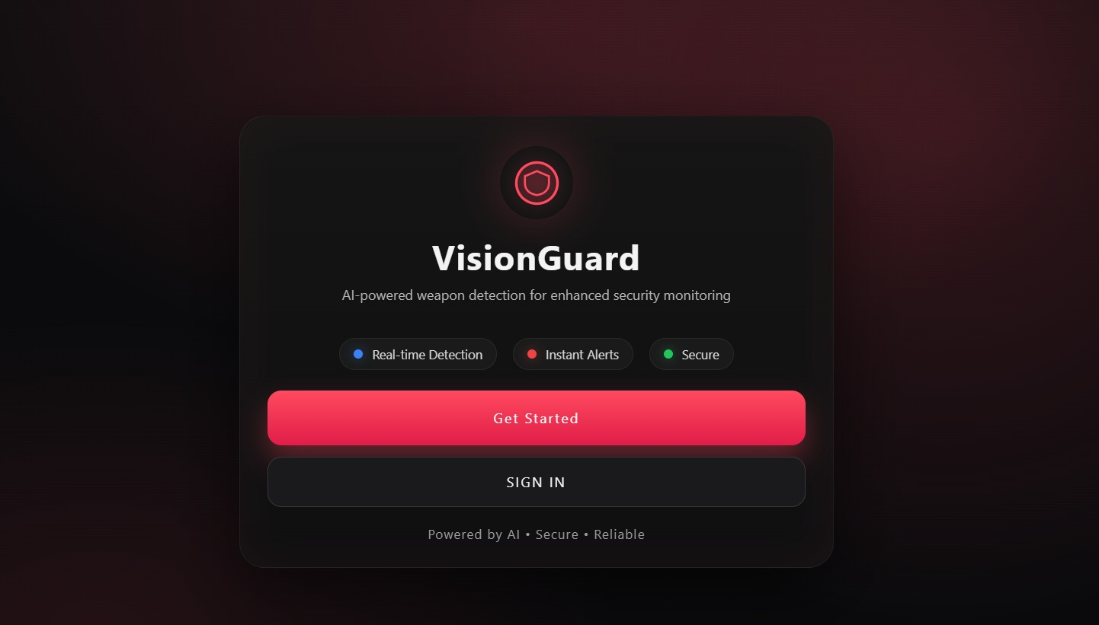
Figure 5.3.1 User Login Interface

Description:

The login screen is like the gate for the system. Only people who are allowed to use it can get in by typing in their username and password. The screen looks simple and dark which helps people focus on getting in. There are two boxes where you type in your username and password.

5.3.2 User Registration Interface:


Figure 5.3.2 User Registration Interface
Description:

The registration screen is for new users to create an account. They get to choose an username and a strong password. This screen looks the same, as the login screen. It helps the people in charge of security to add new staff members to the system.

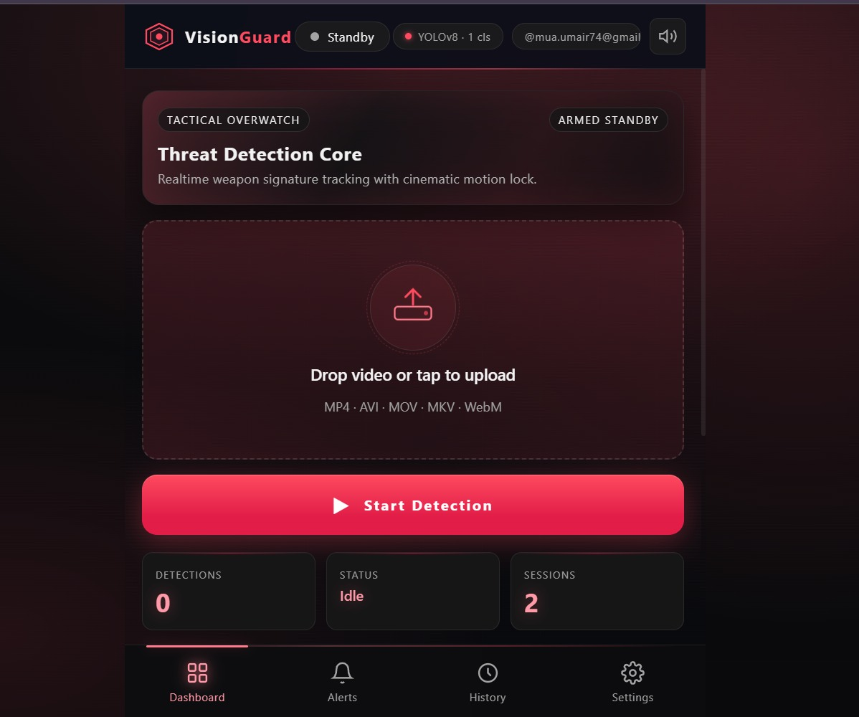
5.3.3 Main Dashboard and File Upload:
Figure 5.3.3 Main Dashboard and File Upload:
Description:

The dashboard is like the control center of our application. It is where users can do all their surveillance tasks. They can also upload their video files here for analysis. The dashboard has an area where users can easily drag and drop files. This makes it simple for the operator to choose the footage they want our AI to check for threats. The operator can just pick the video files they want to scan. Our AI will then look for threats, in those files. The dashboard is really easy to use. It helps users manage their tasks and get the analysis they need.

5.3.4 Detection Alert Gallery:

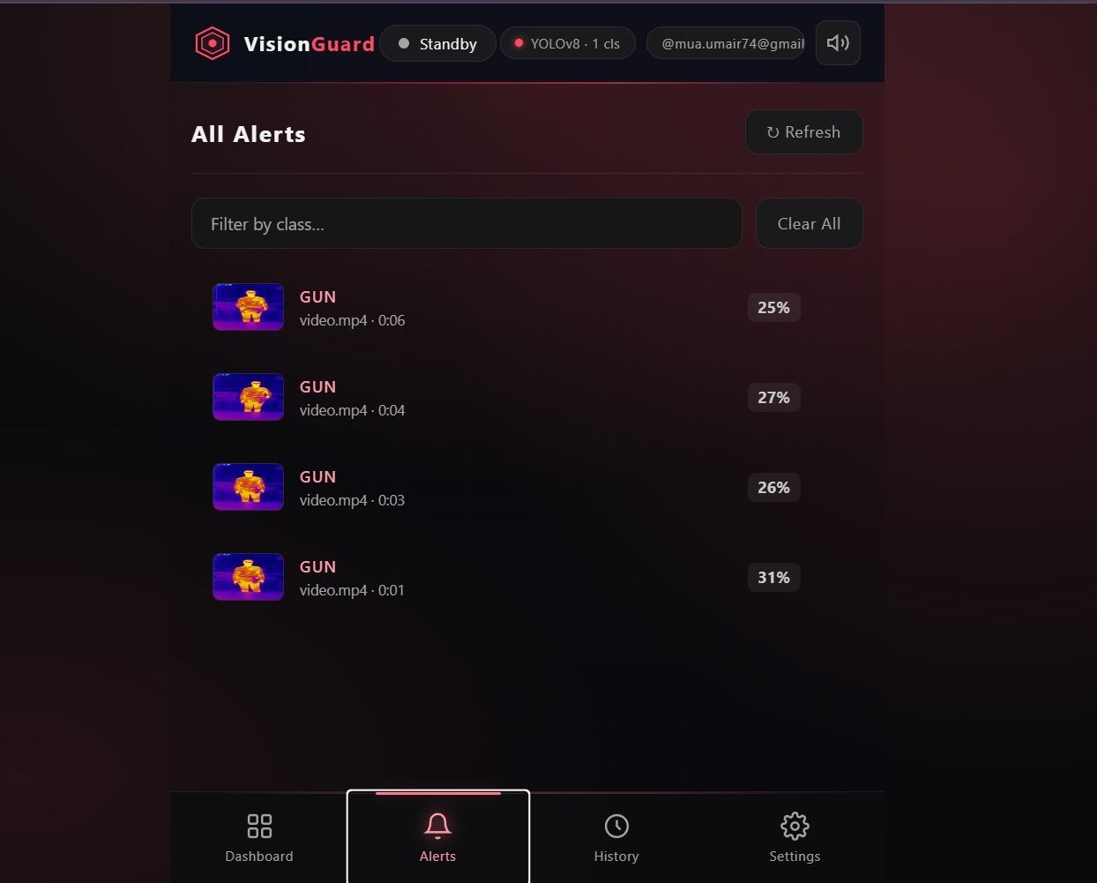
Figure 5.3.4 Detection Alert Gallery
Description:

The alert gallery provides a detailed look at the objects identified by the system, displaying the class of the weapon and the confidence score of the detection. This screen is crucial for providing visual evidence and specific data points to the user so they can quickly verify the severity of the identified threat.

5.3.5 Session History and Logs:
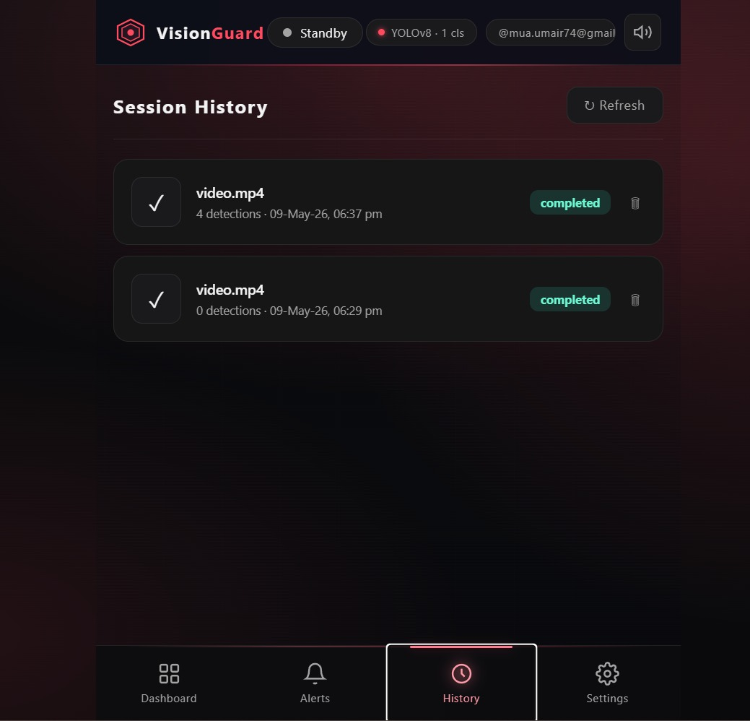
Figure 5.3.5 Session History and Logs
Description:

The history screen acts as a database log where all previous monitoring sessions are recorded and listed for future reference. Each entry shows the video name, the number of detections found, and the timestamp, allowing users to keep a permanent track of security incidents or delete old records.

5.3.6 System Settings and Configuration:
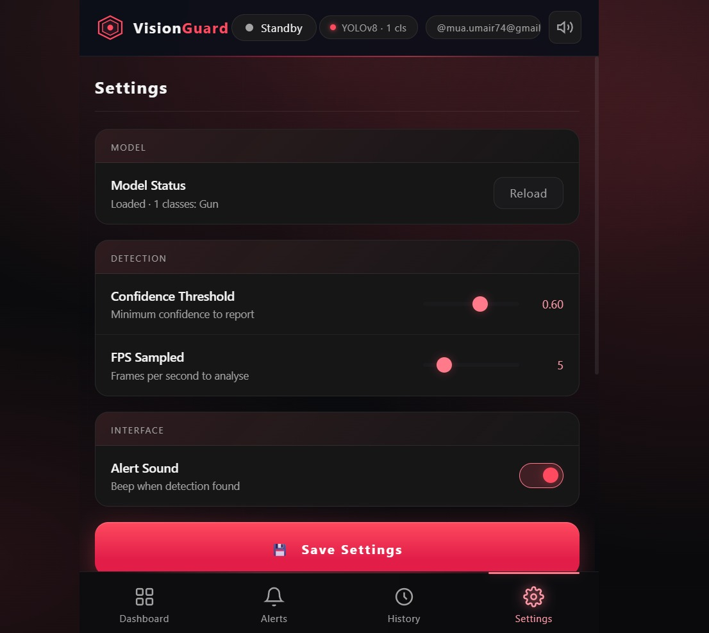
Figure 5.3.6 System Settings and Configuration:
Description:

The settings part of the program lets the user change how the system works. You can adjust the AI confidence threshold and the speed at which it looks at pictures. The settings also have options to turn alert sounds on or off. This means the software can be set up to work well in security situations. The user can customize the systems behavior to meet the needs of the security environment they are, in by using the settings interface to adjust the AI confidence threshold and other options.

5.4 Deployment:
The “Vision Guard” system is deployed using a distributed architecture to ensure scalability and performance. The front-end application, built with React JS version 19.2 is hosted on Vercel. This makes sure it works well and is always available. The back-end services use FastAPI version 3 and Python version 3.11. They are deployed on Render. Render handles the server-side tasks and AI model processing. For storing data Supabase 2022 is used as the PostgreSQL database. It keeps user data and detection logs safe. During development and testing the system was tested on a computer. This ensured that the FastAPI backend and React frontend worked well together. After that was it moved to the cloud. The development process was helped by Visual Studio Code 2024. It was the tool used for writing code. Canva version 2.0 was used for designing the user interface and other visual assets. This combination of cloud hosting and development tools makes the system strong and reliable. It is good, for detecting weapons in time.
- Frontend Deployment Interface (Vercel):
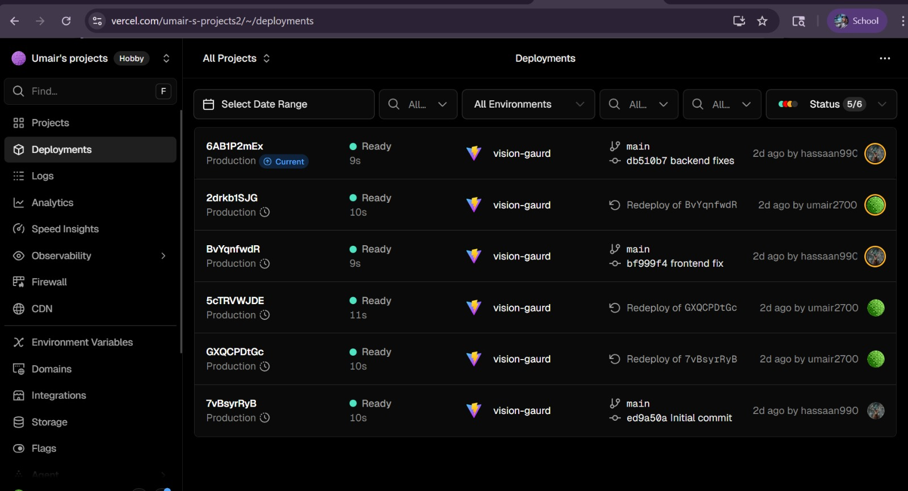
- Backend Hosting Environment (Render):
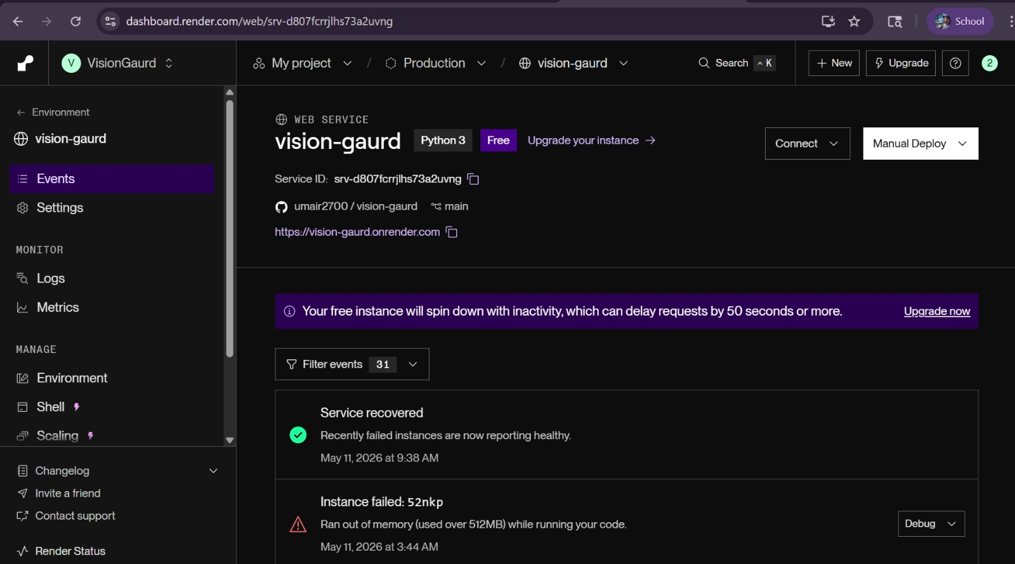

Chapter 6

Testing and Evaluation

6.1 Unit Testing:
Unit testing is performed to verify that each module of the “Vision Guard” system functions correctly and independently.

6.1.1 Unit Testing 1: Thermal Image Pre-processing Module
Testing Objective:
To verify that the thermal image pre-processing module correctly normalizes and resizes thermal frames before passing them to the detection engine.
No. | Test Case / Test Script | Attribute and Value | Expected Result | Result
1 | Resize thermal image | Image size = 640×640 | Image resized successfully | Pass
2 | Normalize thermal frame | Pixel normalization enabled | Pixel values normalized correctly | Pass
3 | Invalid image input | Corrupted thermal image | Error handled without a crash | Pass

6.1.2 Unit Testing 2: YOLOv11 Model Loading
Testing Objective:
To ensure that the trained YOLOv11 model loads correctly and performs initialization successfully.
No. | Test Case / Test Script | Attribute and Value | Expected Result | Result
1 | Load trained model | Best.pt model file | Model loads successfully | Pass
2 | Invalid model path | Wrong model directory | Error message displayed | Pass
3 | GPU availability | CUDA enabled | GPU detected successfully | Pass

6.1.3 Unit Testing 3: Model Loading
Testing Objective:
To verify that the alert module generates visual and auditory notifications properly.
No. | Test Case / Test Script | Attribute and Value | Expected Result | Result
1 | Trigger visual alert | Weapon confidence > threshold | Warning displayed on dashboard | Pass
2 | Trigger sound alert | Hidden handgun detected | Alarm sound activated | Pass
3 | No weapon detected | Normal thermal frame | No alert generated | Pass

6.1.4 Unit Testing 4: Model Loading
Testing Objective:
To verify that detection events are stored correctly in the database.
No. | Test Case / Test Script | Attribute and Value | Expected Result | Result
1 | Save detection event | Weapon detected | Detection saved with timestamp | Pass
2 | Store confidence score | Confidence = 85% | Score stored correctly | Pass
3 | Retrieve history logs | Previous detection records | Logs displayed successfully | Pass

6.2 Functional Testing:
Functional testing validates whether the system fulfills all specified functional requirements.

6.2.1 Functional Testing 1: Hidden Weapon Detection
Objective:
To ensure that the system accurately detects concealed weapons using thermal imaging.
No. | Test Case / Test Script | Attribute and Value | Expected Result | Actual Result | Result
1 | Detect concealed handgun | Thermal frame with a handgun | Handgun segmented and detected | Detected Successfully | Pass
2 | Detect a concealed knife | Thermal frame with a knife | Knife segmented and detected | Detected Successfully | Pass

6.2.2 Functional Testing 2: Real-Time Alert Generation
Objective:
To ensure alerts are generated upon weapon detection.

No. | Test Case / Test Script | Attribute and Value | Expected Result | Actual Result | Result
1 | High confidence weapon detection | Confidence > 0.80 | Visual + sound alert triggered | Alert Triggered | Pass
2 | Low confidence object | Confidence < threshold | No alert generated | No Alert | Pass

6.2.3 Functional Testing 3: User Authentication
Objective:
To verify secure login and role-based access control.
No. | Test Case / Test Script | Attribute and Value | Expected Result | Actual Result | Result
1 | Valid admin login | Correct credentials | Access granted | Login Successful | Pass
2 | Invalid password | Incorrect password | Access denied | Access denied | Pass
3 | Session timeout | 20 minutes of inactivity | Session terminated automatically | Session Expired | Pass

6.3 Business Rules Testing:
Business rules testing verifies whether the system behaves according to predefined security rules.
6.3.1 Business Rule: Alert Triggering Logic
Rule No. | Weapon Detected | Confidence Threshold | Action
R1 | Yes | Above Threshold | Generate Alert
R2 | Yes | Below Threshold | Log Detect Only
R3 | No | Any Value | No Action
R4 | Yes | Above Threshold + Admin Active | Generate High Priority Alert
6.3.2 Business Rules Test Cases:
Test Case No. | Rule Applied | Input Condition | Expected Output | Result
1 | R1 | Hidden handgun + 80% confidence | Alert generated | Pass
2 | R2 | Knife + 45% confidence | Detection logged only | Pass
3 | R3 | Normal thermal frame | No alert | Pass
4 | R4 | Concealed weapon in a restricted area | High-priority alert generated | Pass

6.4 Integration Testing:
Integration testing makes sure that many parts work together. It checks that they do not have any problems. This testing is about modules. Modules work together correctly without conflicts, in integration testing.

6.4.1 Integration Testing 1: Thermal Camera and Detection Engine
Testing Objective:
To verify the interaction between the thermal imaging module and YOLOv11 detection engine.
No. | Test Case / Test Script | Attribute and Value | Expected Result | Actual Result | Result
1 | Thermal frame processing | Thermal camera + YOLO model | Hidden weapon detected correctly | Successful | Pass
2 | Continuous frame analysis | 3-minute runtime | Stable processing without lag | Stable | Pass

6.4.2 Integration Testing 2: Detection Engine and Alert Module
Testing Objective:
No. | Test Case / Test Script | Attribute and Value | Expected Result | Actual Result | Result
1 | Weapon detection → alert | Hidden handgun detected | Visual + sound alert generated | Alert Triggered | Pass
2 | No weapon → no alert | Empty thermal frame | No alert triggered | No alert | Pass

6.4.3 Integration Testing 3: Detection Log and Database Module
Testing Objective:
To ensure that detected events are stored successfully in the database.
No. | Test Case / Test Script | Attribute and Value | Expected Result | Actual Result | Result
1 | Save detection history | Weapon detected | Event stored in the database | Stored Successfully | Pass
2 | Retrieve logs | Search by date | Correct logs displayed | Logs Retrieved | Pass

Chapter 7

Conclusion and Future Work
This final chapter summarizes the results of the project and outlines how the system effectively addresses the challenges of weapon detection in thermal imagery. It provides a final assessment of the developed solution and highlights specific areas where the application can be expanded or improved in the future to meet evolving security needs.

7.1 Conclusion:
The “Vision Guard” system is really good at finding weapons in videos. It uses a tool called the YOLOv11 model to do this. The Vision Guard system can find threats even when it is dark or something is in the way. The Vision Guard system has some features. It has a way for users to log in. It also has alerts that show up away and make noise. The Vision Guard system keeps a record of what happened. All of these things are easy to use and look professional. This means that people in charge of security can trust the Vision Guard system to always be working and help them make decisions when something bad is happening.
The Vision Guard system is also very useful, for people who watch over places and keep them safe. It is easy to use and works with the systems that already exist. The successful implementation of the dashboard, real-time alert gallery, and customizable settings allows users to tailor the system’s sensitivity to their specific operational needs. By bridging the gap between advanced deep learning models and a practical software application, this project proves that automated weapon detection is a viable and efficient way to enhance public safety. Ultimately, the system provides a robust foundation for proactive threat prevention, reducing the response time of security teams and potentially saving lives.

7.2 Future Work:
The system is going to be a lot better in the future. We can make this happen by changing how it works. Now it uses files but we can make it work with live video instead. This means we can connect the intelligence to cameras that use internet connections or to closed circuit television networks. Then we can watch what is going on all the time twenty four hours a day seven days a week without having to upload videos by hand.
The system can also get better at finding things that might be a problem. We can teach it to recognize different kinds of things that could be a threat, like containers that hold chemicals or packages that look suspicious in addition to things like guns. The system will also be able to see how people are behaving. It can flag things that look aggressive or suspicious like someone hanging around a place they should not be. This will make the system a lot smarter and better at keeping people safe it is not about seeing objects it is, about understanding what is going on with the security cameras and the artificial intelligence and the system.
Another key area for future development is the implementation of a cloud-based alert system and mobile compatibility. By developing a dedicated mobile application, the system could send instant push notifications and high-resolution snapshots of detected threats to the smartphones of security officers on patrol. Additionally, the integration of edge computing would allow the AI model to run locally on camera hardware, significantly reducing latency and bandwidth usage. These improvements would transform the current application into a highly scalable, enterprise-level security network capable of protecting large public spaces, with even greater speed and precision.

References:
J. Redmon and A. Farhadi. It was published in Seattle, Washington by Tech Press in the year 2021. The pages I am looking at are from 45 to 89. Real-Time Object Detection, with Deep Learning is really interesting
S. G. Burney. Thermal Imaging and Security Systems. London: Surveillance Media, 2018, pp. 210-235.
A. Bochkovskiy. "Optimizing YOLO Models for Security Surveillance." The International Journal of Computer Vision and AI, vol. 12, pp. 102-125, March 2024.
R. Khan and M. Ahmed. "Thermal Spectrum Analysis for Weapon Identification." Journal of Infrared Physics & Technology, vol. 45, pp. 12-30, June 2025.
T. Sultana and S. Ali wrote about detecting weapons in time using YOLOv11 in low-light environments. They presented their findings at the International Conference on Intelligence and Safety (ICIS) in 2026. Their paper is on pages 88 to 95.
V. Sharma discussed advancements in automated surveillance systems at the Global Security Forum in 2025. His paper covers pages 301, to 315.
Ultralytics. "YOLOv11 Documentation and Implementation Guide." Internet: https://docs.ultralytics.com/models/yolov11/, Jan. 10, 2026 [May 12, 2026].
Python Software Foundation. "Flask Web Framework Documentation." Internet: https://flask.palletsprojects.com/, Nov. 15, 2025 [May 10, 2026].
OpenCV Team. "Open Source Computer Vision Library." Internet: https://opencv.org/, Feb. 20, 2026 [May 12, 2026].

